Model - visualisation of the "Red Garden" sports complex in Boskovice

Boskovice elementary school, contribution organisation
náměstí 9. května, Boskovice 68001

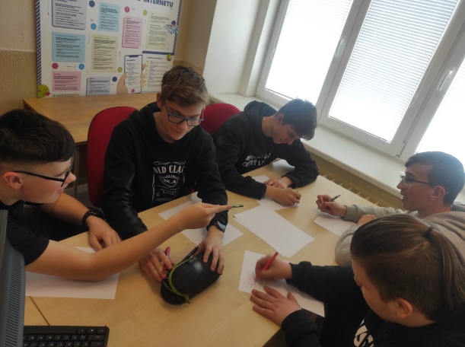 | 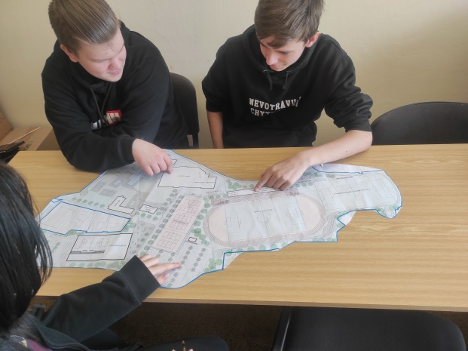
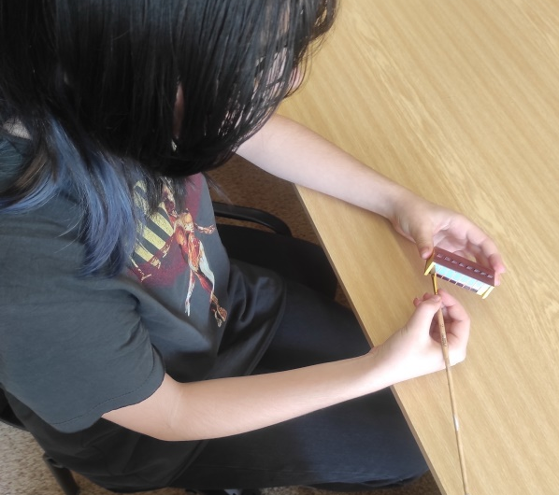 | 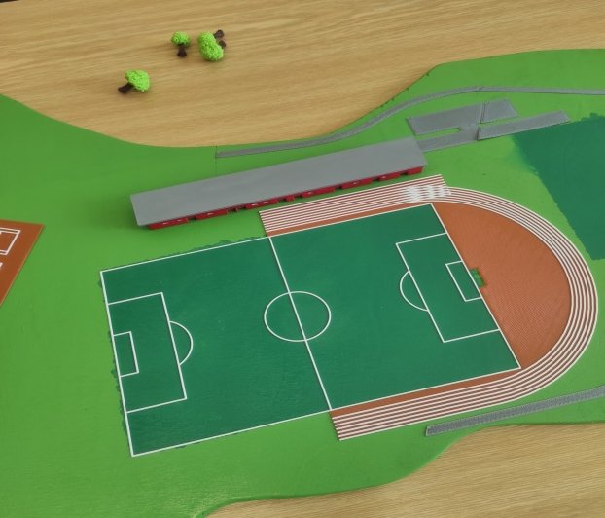

Annotation
In cooperation with the city of Boskovice, create a model of the "Red Garden" sports complex in Boskovice. We will use work in 3D editors, print on a 3D printer and create the ground for the terrain with a cutting LASER plotter, add minor adjustments and inaccuracies with a 3D pen.

Contents:
Annotation 2
Project information 5
Description of the situation 5
Project goal 11
The final option 12
Who is the project intended for? 14
Required material equipment 15
Financial calculations 19
The appetite for work – priceless! 19
Time schedule 20
The share of the work of the leading pedagogues 21
Workflow 22
Motherboard 22
Roads, parking lots 23
Winter stadium 24
Swimming pool "Červenka" 25
Entrance building 25
Locker rooms 26
Toilets, umbrellas, benches 27
Changing rooms 28
Water slide 29
Bridge over the water 30
Aquapark 31
Wastewater treatment plant 32
Multipurpose hall 33
Athletic oval 34
Football stadium 35
Flat 35
Football locker rooms 36
Football stadium accessories 37
Administrative building 38
Bowling alley 39
Hostel 40
Substation 41
Volleyball courts 42
Tennis courts 43
Parking 44
Nature 45
Completion of the model 46
A table with the name of the project 47
The final form of the project 50
Competition on 5/26/2022 in VIDA 51
Evaluation of the project 52
Used SW and tutorials 52

Project information

Description of the situation
One serious problem of a sporting nature that has been going on in Boskovice for decades. We do have solid sports use – especially in the Red garden area. Here we have recently built a covered winter hall, used by the SKMB Minerva Boskovice sports club for regional hockey league matches, for public ice skating, in the summer for inline hockey, ice hockey, indoor soccer, futsal, floorball or a summer dormitory.
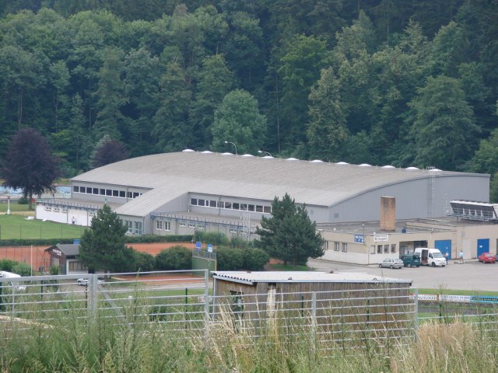

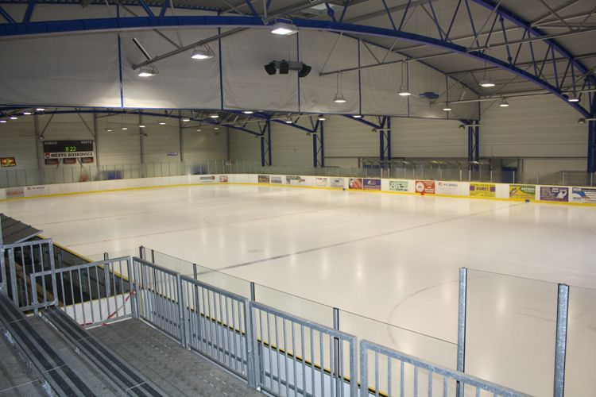

We also have two football stadiums – grass and artificial grass. Among others, FC Boskovice plays on them.

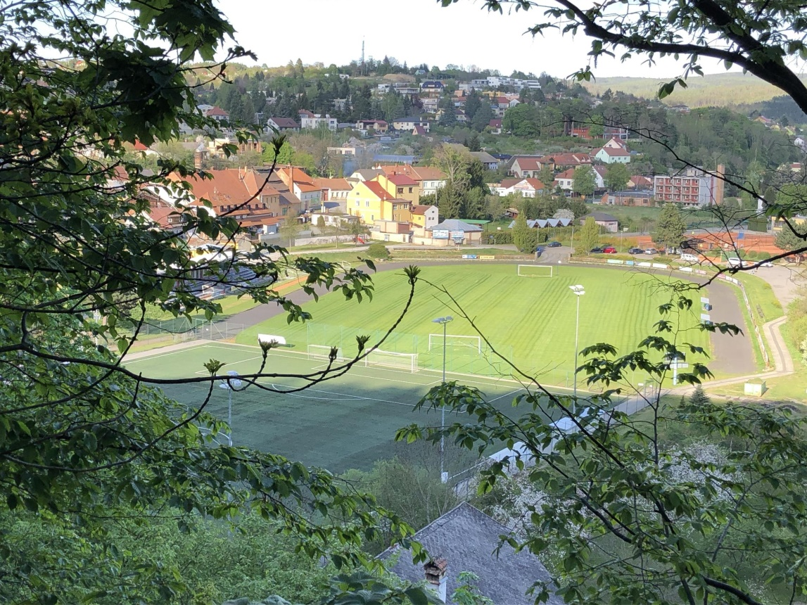

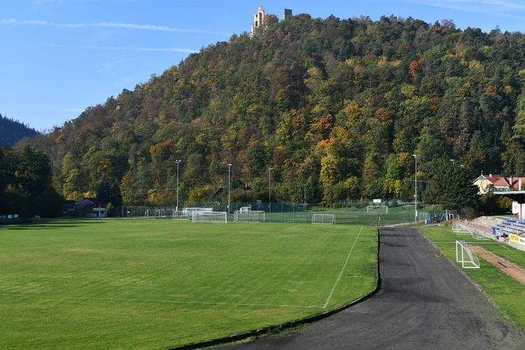

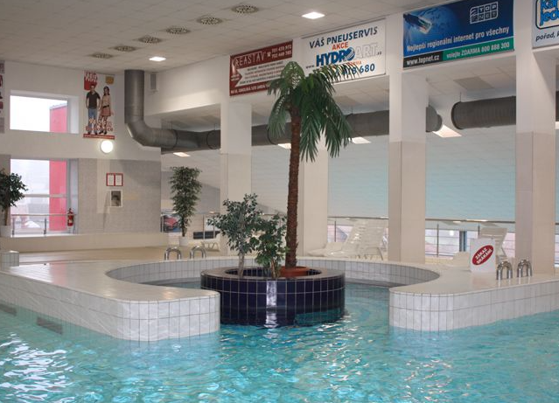
We have a reconstructed city bath and sauna

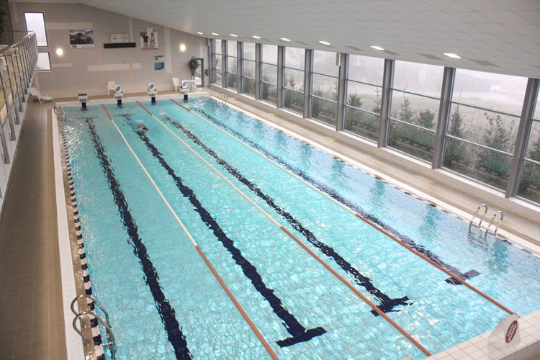

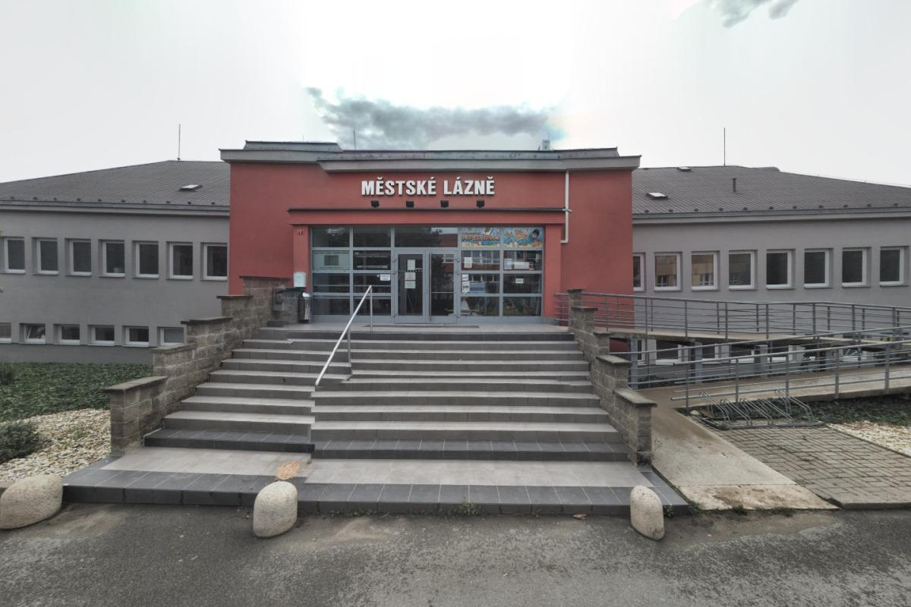

In 2010, the Červenka swimming pool was completely rebuilt
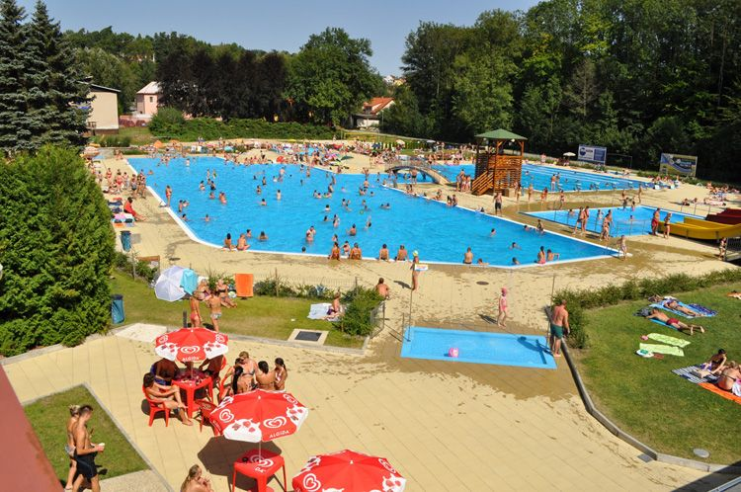

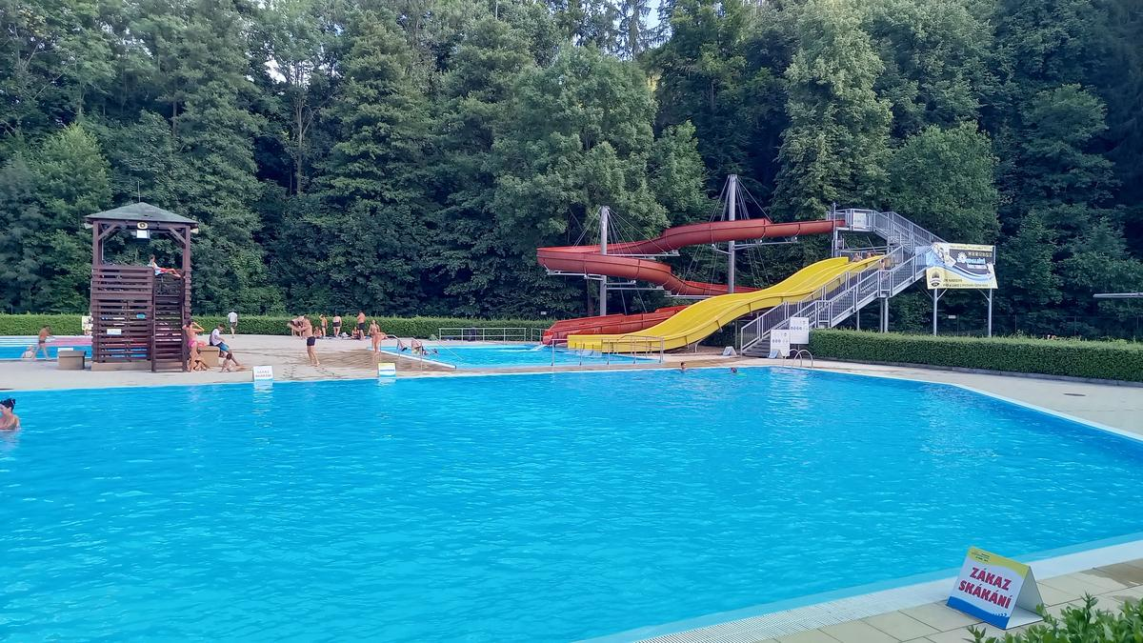

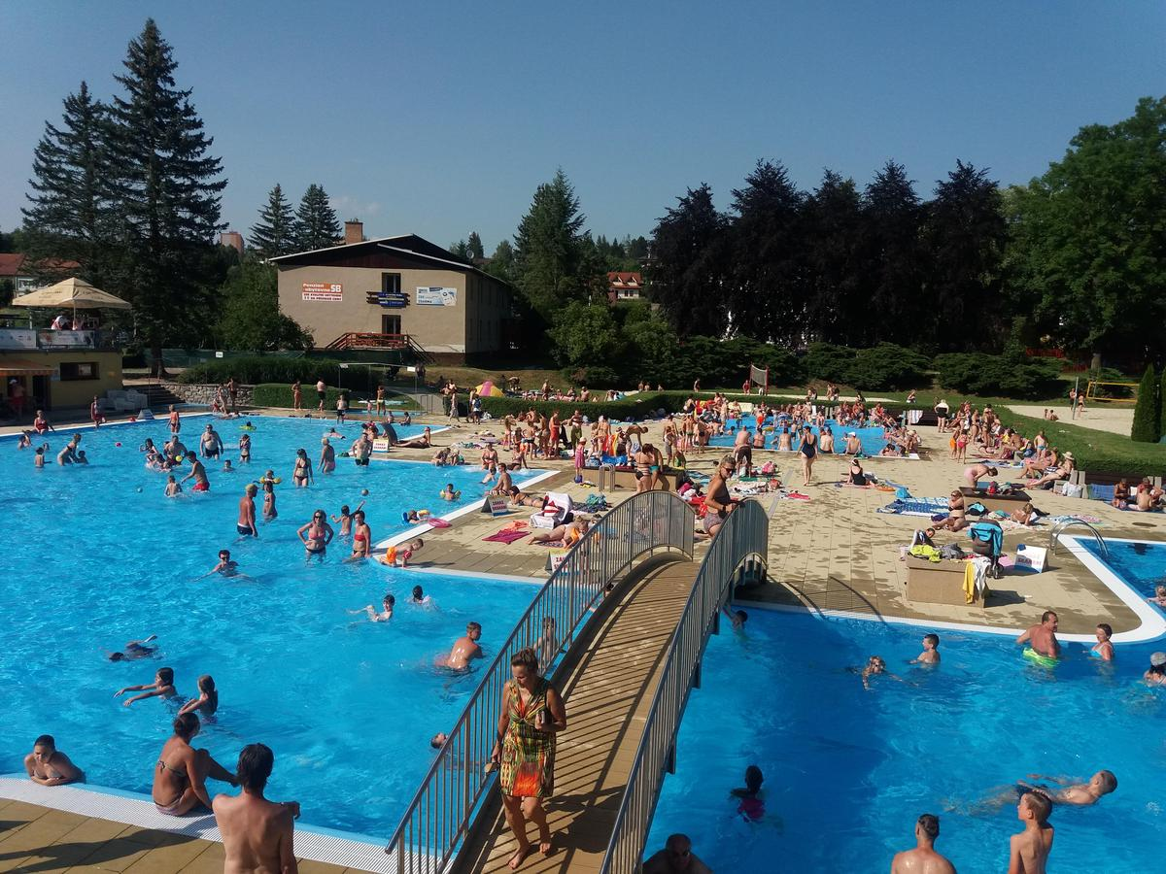

We have a Sportpark with bike rental and almost 10 kilometres of singletrail tracks - mostly through the forest.
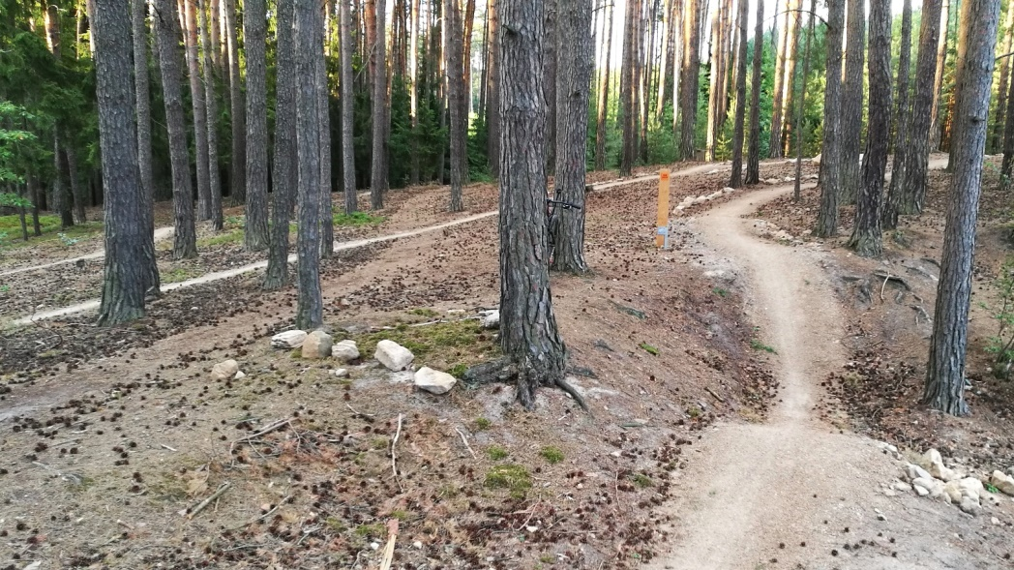

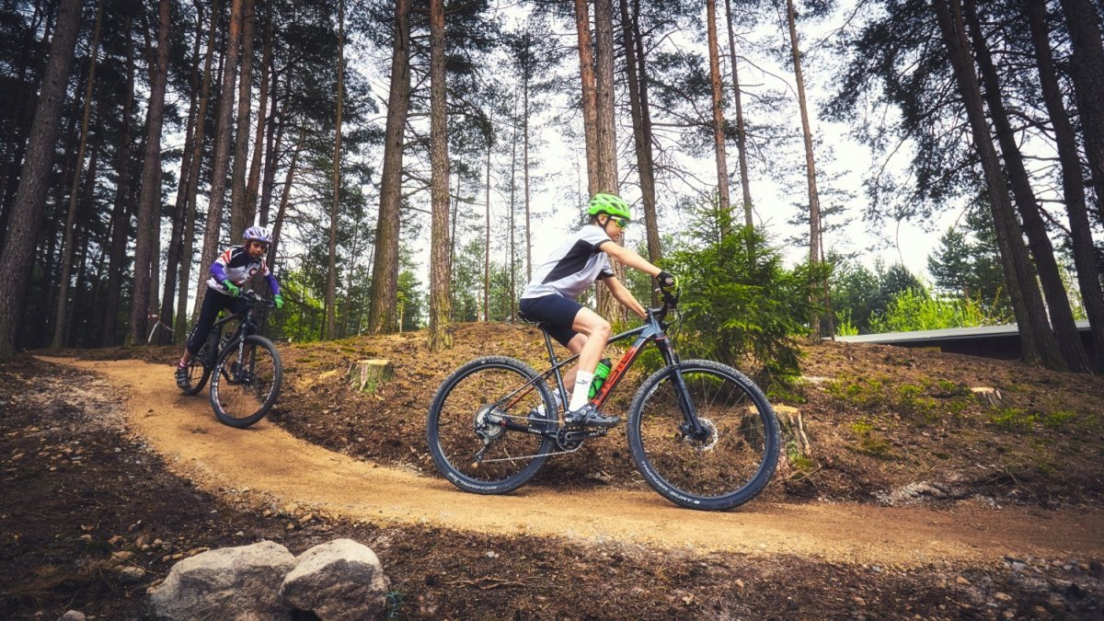

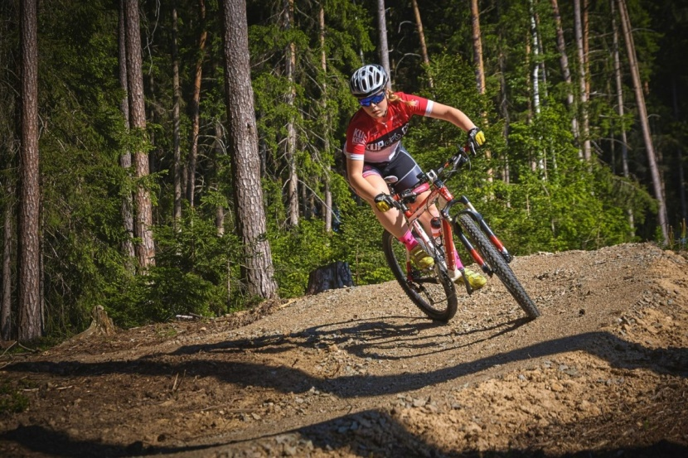

We have several pitches for small football, skittles, bowling…
BUT, since the nineties, we have NOT had a SPORTS HALL for our basketball players, volleyball players, netball players and others. These sports are placed in the gymnasiums of the local primary and secondary schools or in the beautiful new hall – in neighbouring Svitávka
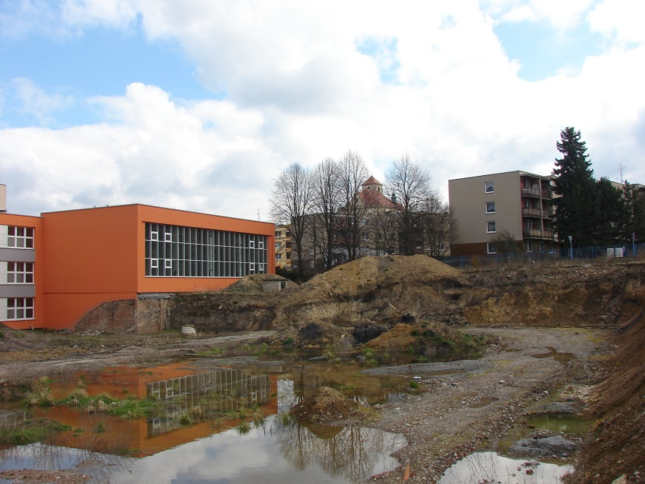
For at least ten years and the third term of office of the city hall, it has been decided where to build it. The original version in the premises of one of the elementary school buildings on Slovákova Street was dropped due to protests by residents from the surrounding streets and an insufficiently performed inspection of the subsoil with groundwater.
Other variants with the demolition of 2 gymnasiums of the second primary school building on Sušilova Street or in the area of ​​the local secondary school on Hybešova Street also fell through.
In the end, some plots of land in the Red Garden area and nearby were bought out. The Velen Hotel, which had been in a state of disrepair for many years, was demolished, and it was decided to build not only a new hall, but also to completely renovate the entire area, including tennis courts, football stadiums, athletics tracks, ...
Unfortunately, there was no agreement here either, and as the city leadership and opinions of the opposition, citizens and athletes themselves change, countless variants have arisen.

Development of the sports hall in time

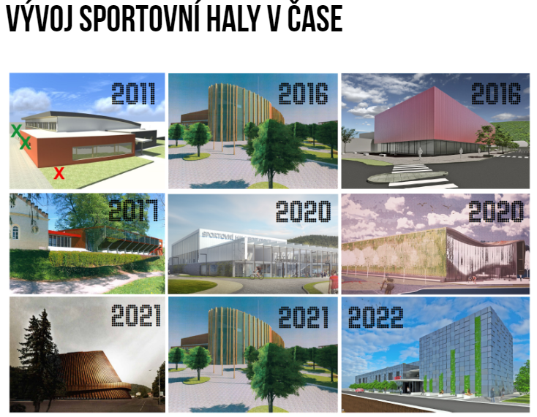

Project goal
We decided to create a 3D model of the future sports complex in the Red garden complex in Boskovice.
Unfortunately, just like the design of the hall, the design of the entire area is constantly changing. But we had to come up with something for our work. I am adding some of the variants as an example
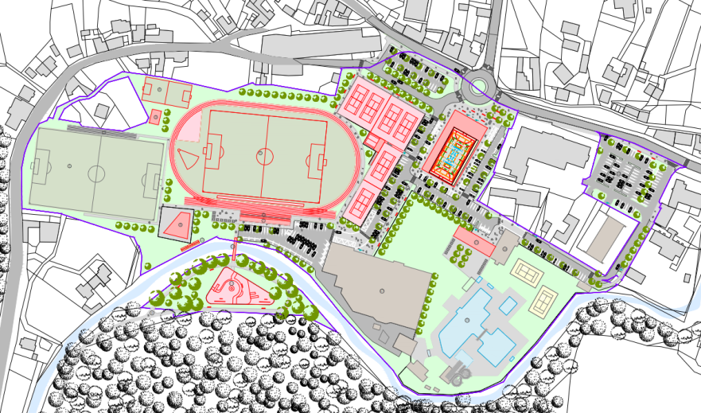

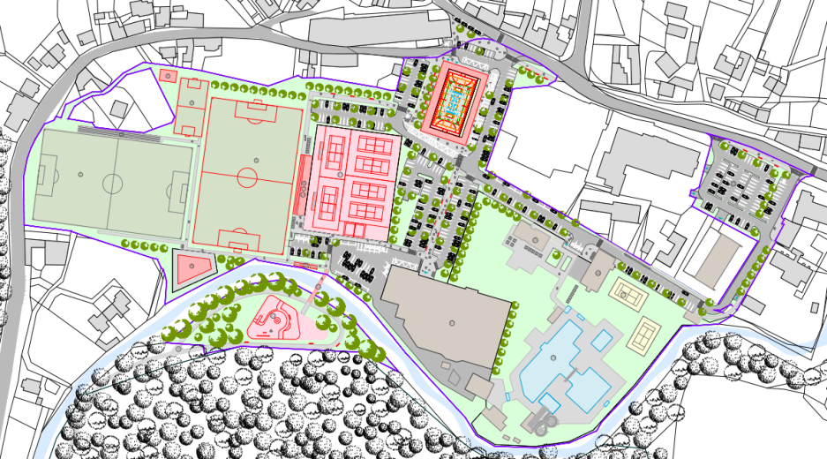

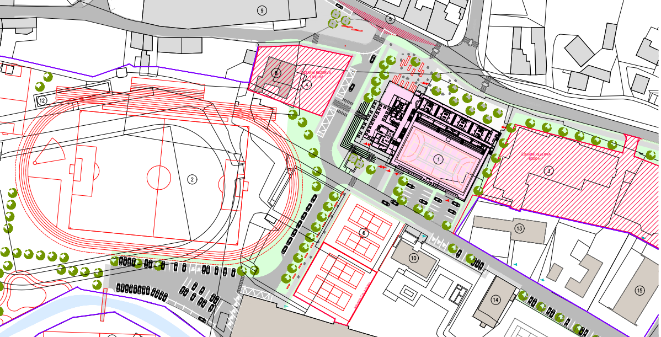

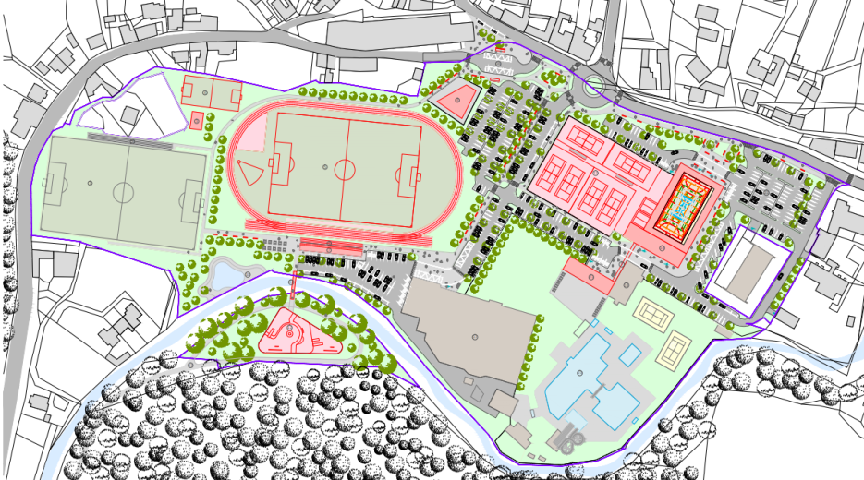

The final option
We therefore adjusted our resulting project in accordance with the changes, but even so, the current version is unfortunately still not confirmed. From the various proposals that the city had prepared, we chose option 1 of the architectural-urban study of the Red garden sports complex by Zdeňko Fránek.

Here is the most likely variant of the future campus. And for us a sample of the created 3D model.

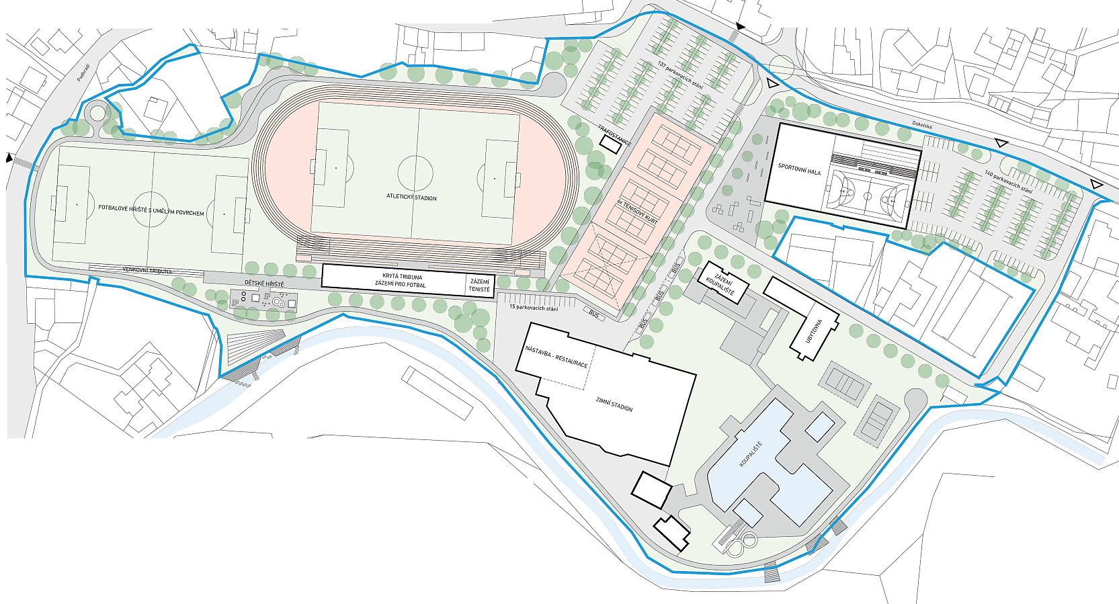

Who is the project intended for?
Due to the complexity of the project
8th and 9th graders took part here, from which a group of the most persistent and fittest stood out:

Adam Kamila Tereza

Daniel Adam Adam

Skills to be mastered by students
Drawing and modelling in a 3D editor
Cutting and engraving using a LASER plotter
Working with a vector graphics editor
Work with 3D pens including various additional attachments
Working with an airbrush kit for painting models
Work with data

The goal of the project was to deepen students' knowledge of 3D modelling and 3D printing. To develop their logical, technical and graphic thinking. Work in a team, develop social, communication, digital and work competences.

Required material equipment

As part of the project's material support, we acquired a Prusa MK3 3D printer, including an extension for multi-color printing..
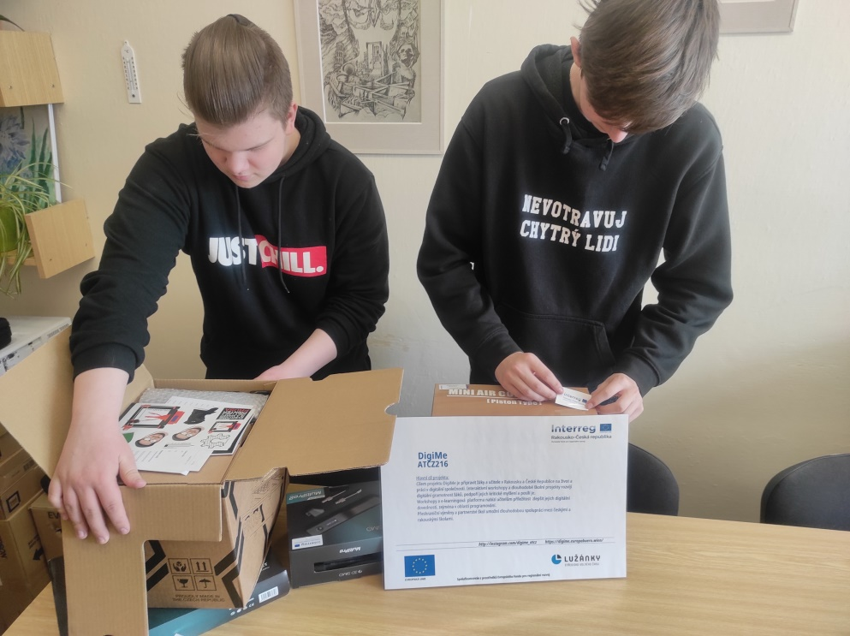

- LASER plotter model K40
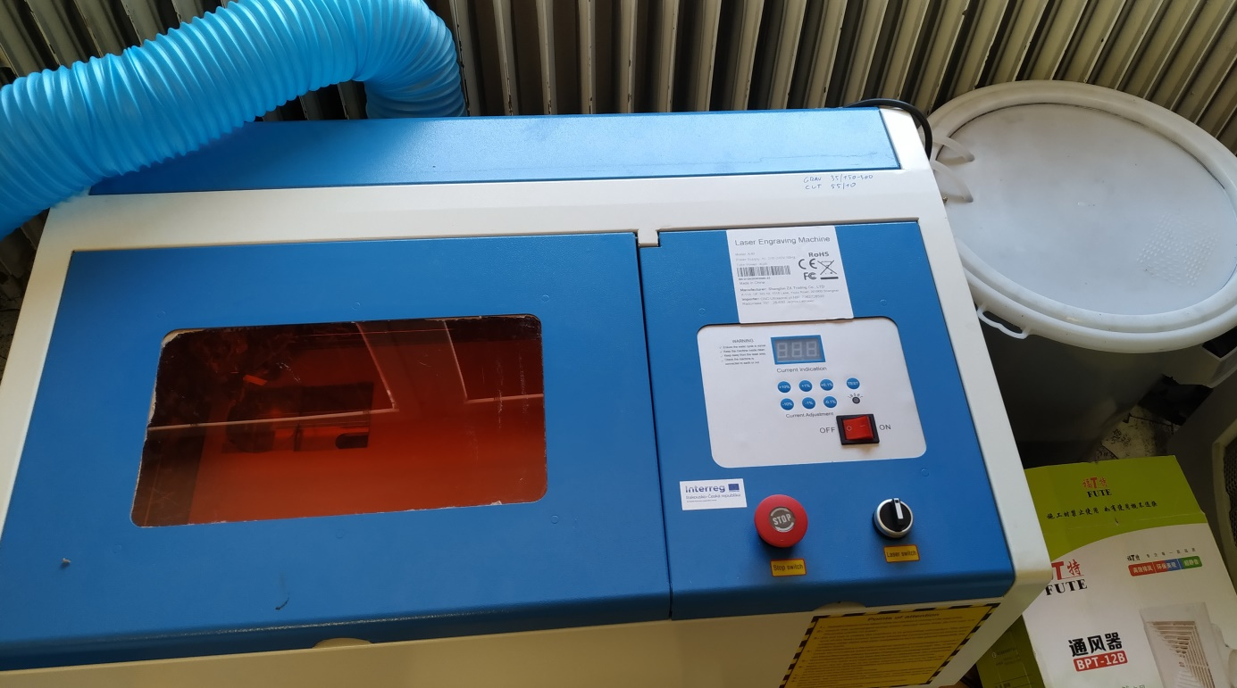
- Airbrush set including compressor and paint set

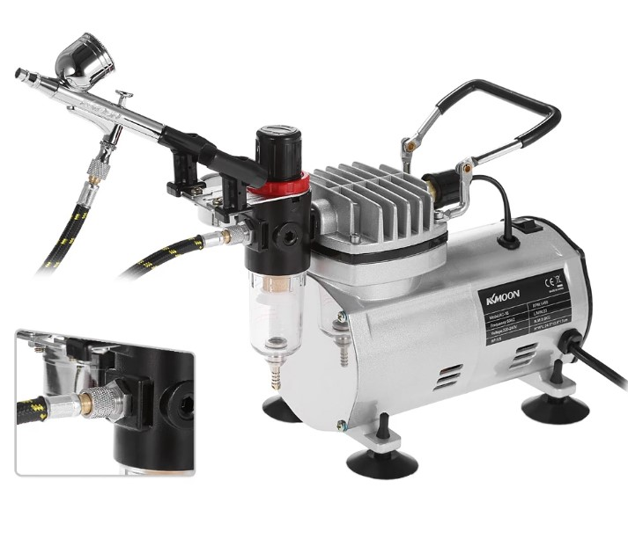
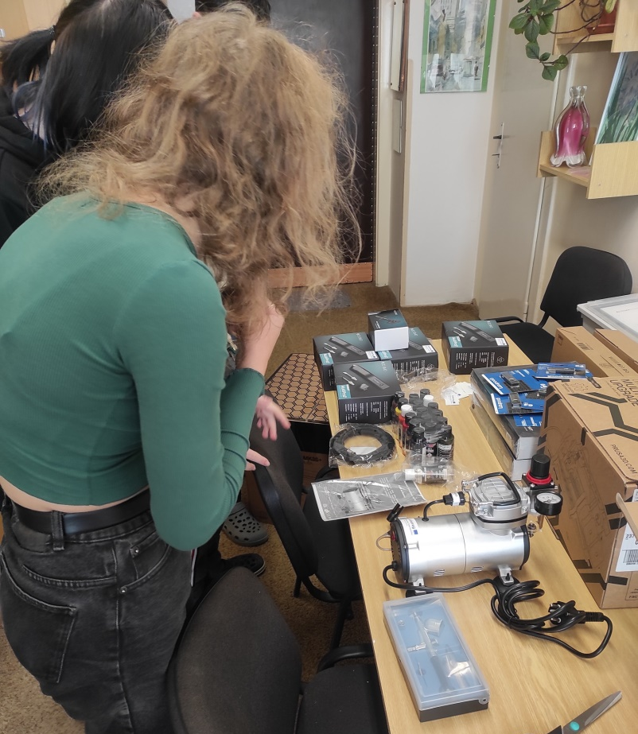

- 3D pen set including spare attachments for drilling, cutting, grinding or perhaps soldering
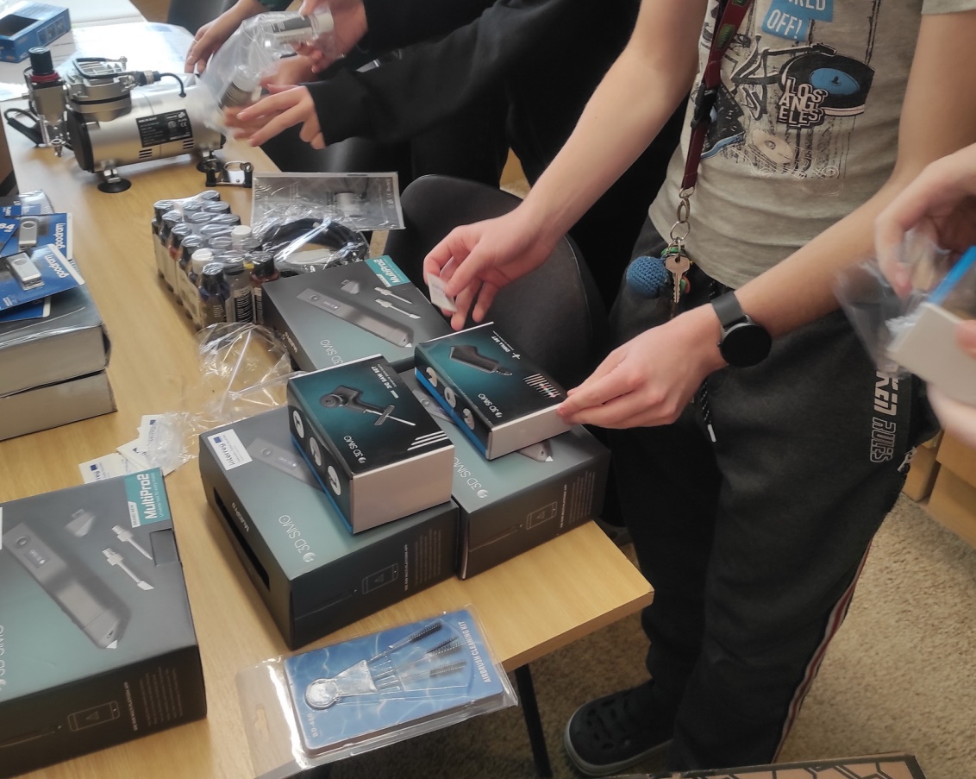

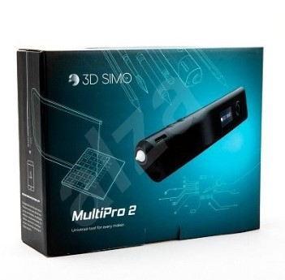

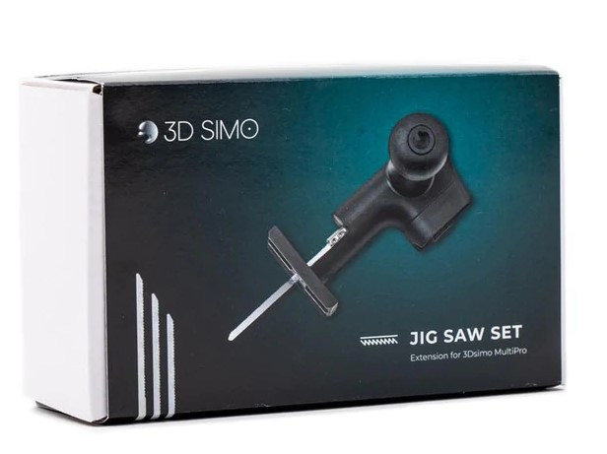
3D pen

Attachment for 3D pen - saw

- 2 x external SSD HDD 1TB and 10x 64 GB flash drive
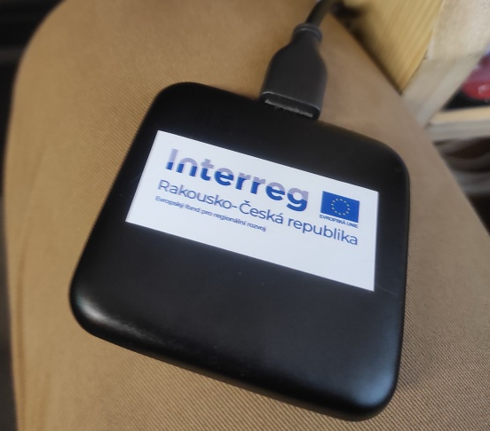

- Consumables – filaments for 3D printers and 3D pens, paints, thinners
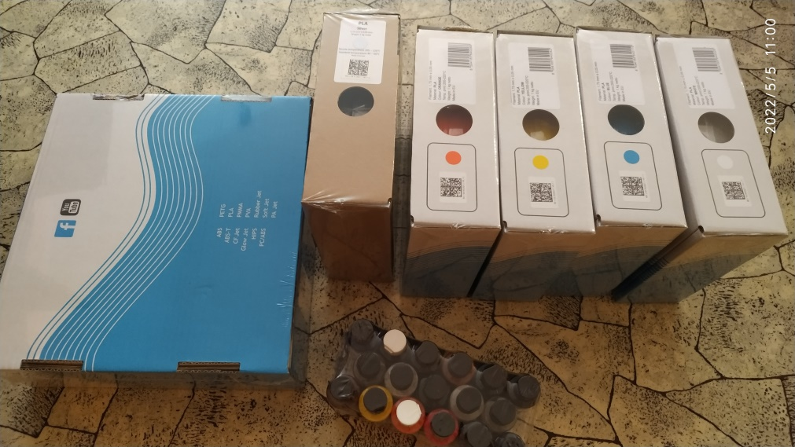

From our own resources, we then used ordinary laser printers, brushes and water lines, as well as saws, files, scissors, glue, scalpels...

Financial calculations
Financial budget
3D printer PrusaMK3 | 1 | 27 000,00 CZK | https://shop.prusa3d.com/cs/3d-tiskarny/181-3d-tiskarna-original-prusa-i3-mk3s.html
Multimaterial Prusa | 1 | 7 600,00 CZK | https://www.prusa3d.cz/original-prusa-i3-multi-material-2/?gclid=CjwKCAjw_JuGBhBkEiwA1xmbRRXTXJpAk_xJeTu2Is4vNZCl4oN0mdneIlB3eef-7P2ZjnJnuWGJDBoCzZ8QAvD_BwE
3D pen with attachments | 4 | 12 000,00 CZK | https://www.peckamodel.cz/g3d1008-3d-pero-3dsimo-multipro-3-nastavce
Extensions for the 3D pen | 2 | 2 000,00 CZK | https://www.peckamodel.cz/g3d2014-3d-pero-multipro-nastavce-rezani-foam-cutting
Extensions for the 3D pen | 2 | 2 000,00 CZK | https://www.peckamodel.cz/g3d2015-3d-pero-multipro-nastavce-primocarka-jigsaw
Extensions for the 3D pen | 2 | 2 000,00 CZK | https://www.peckamodel.cz/g3d2017-3d-pero-multipro-nastavce-vrtacka-driller
Laser plotter | 1 | 23 000,00 CZK | https://www.cncworld.cz/laserov-plotr-co2-40w-35x24cm-air-assist-red-point-p-67.html//www.lior.cz/laserove-gravirovaci-nastroje/40w-co2-usb-laserovy-gravirovaci-rezaci-stroj/
AirBrush | 2 | 6 000,00 CZK | https://www.streetkolor.cz/www-streetkolor-cz/AIRBRUSH-SET-NA-DORTY
Airbrush colours set | 2 | 6 000,00 CZK | https://www.streetkolor.cz/www-streetkolor-cz/17x60ml-Wicked-detail-sada-I-d609.htm
Thinner | 2 | 300,00 CZK | https://www.streetkolor.cz/www-streetkolor-cz/CREATEX-5618-60ml
External SSD HDD 1TB | 2 | 6 000,00 CZK | https.//www.czc.cz
Flash drive 64 GB | 10 | 3 500,00 CZK | https.//www.czc.cz
PET-G filament | 5 | 2 500,00 CZK | https://www.prusa3d.com/cs/kategorie/prusament-pla/
plywood boards | 5 | 100,00 CZK | https://www.truhlarstvi-parolek.cz/nase-sluzby/
EXTOL Craft Carving Knife Set, 91350 | 1 | 199,00 CZK | https://www.datart.cz/sada-extol-craft-vyrezavacich-nozu-91350.html?gclid=CjwKCAjw682TBhATEiwA9crl36fGtscRJYxzmJFhhXOD70hOOgQ83ZeclTachO4t864jfjp_2DtfzRoCGV8QAvD_BwE
Acrylic paints - 24 x 12 ml + 3 x brush – ACR2412 | 1 | 235,00 CZK | https://proradost.kreativnibrabec.cz/zbozi/akrylove-barvy-24-x-12-ml-3-x-stetec-acr2412/?gclid=CjwKCAjw682TBhATEiwA9crl37WlvVDUB-IA5MduMRIU0ovadjwFe70x0Hidc6DVElMVMCc7VCzLHRoCc0wQAvD_BwE
Adhesive | 2 | 80 CZK
In total |  | 100434,00 CZK

The appetite for work – priceless!

Time schedule
Acquaintance of students with the project, distribution of tasks and functions 2
Acceptance of devices and aids from the project 2
Analysis of plans and choice of the most suitable option 2
Preparation of the model plan, recalculation of the scale 2
Getting to know Inscape and K40 Whisperer for working with a laser plotter 3
Cutting and modifying the base plate 2
Getting to know and working with the graphic program Blender 2
Getting to know the Tinkercad.com 3D editor 2
Programming of buildings and other parts of the site 15
3D printing of objects 20
Colour treatment of objects – airbrush, manual colouring 6
Assembling a model from printed and colored objects 5
Finishing work 3
Working with a 3D pen 10

The share of the work of the leading pedagogues
Most elementary school children are just getting to know the 3D printing program, so before starting the project itself, enough time was devoted to trying out work with the Tinkercad online editor. Pupils first learned to create simple objects - cubes, cylinders, and to place holes in them (the basis of work for bud
teaching the construction of buildings with windows and doors) Furthermore, more complex objects, e.g. using the school's 3D scanner.
Another task was to teach the children to work with the Blender graphics program, designed for modelling and rendering three-dimensional computer graphics.
The created models had to be programmatically cut into individual layers. Pupils learned to work with PrusaSlicer. Edit and set the number of layers. Decide if and where supports are needed so that everything leads to a successful printing of the model.
Even working with 3D pens, which are equipped with electronics and a number of attachments, first required a number of attempts to acquire the skill.
Most of the children did not know the airbrush set with a compressor. Special safety precautions were required here due to working with thinner and paints. The children had to be equipped with protective glasses and preferably also gloves and work clothes.
The strictest rules were when working with a laser plotter. The students created images in the Inkscape program intended for use on the plotter and prepared them for engraving using the K40 Whisperer application. Then they took turns at the plotter one at a time under the supervision of the head teacher. Always with special glasses and observing strict safety.
Pupils were led both to make independent decisions and to use their own ideas and imagination – they created models themselves based on photos and plans, but also to cooperate within the collective, when they had to work together on a lot of ambiguities and inaccuracies in the individual objects of the model.
In addition to leading and correctly directing children, the work of pedagogues was primarily organisational and administrative work.

Workflow

Motherboard
After the final decision for the most anticipated variant of the future campus, the students enlarged the plan to the dimensions corresponding to the future model. Due to its size, the print had to be divided into several parts. Then assemble and glue them. We used five-layer plywood as the base part.

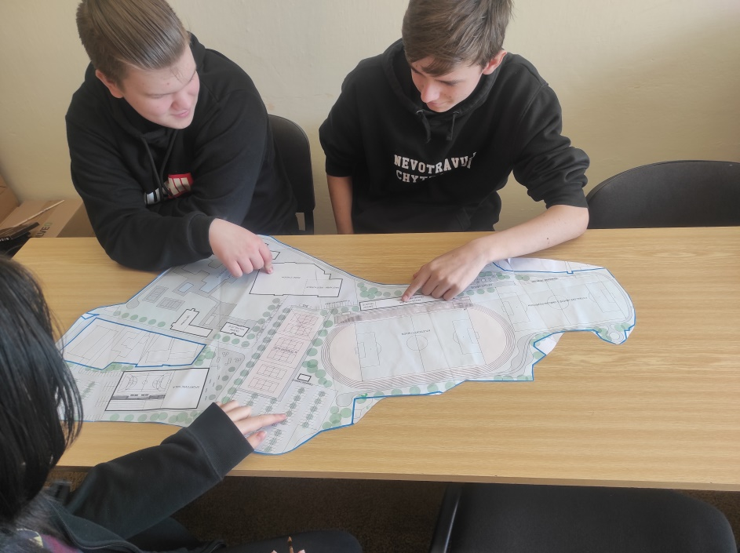

The plan was pressed onto several plywood boards and work followed with the help of a jigsaw bought from the project, sandpaper and the assembly of the future mat. Using an airbrush set, the finished board was colored in its final form to light green, and the football field grass to dark green.
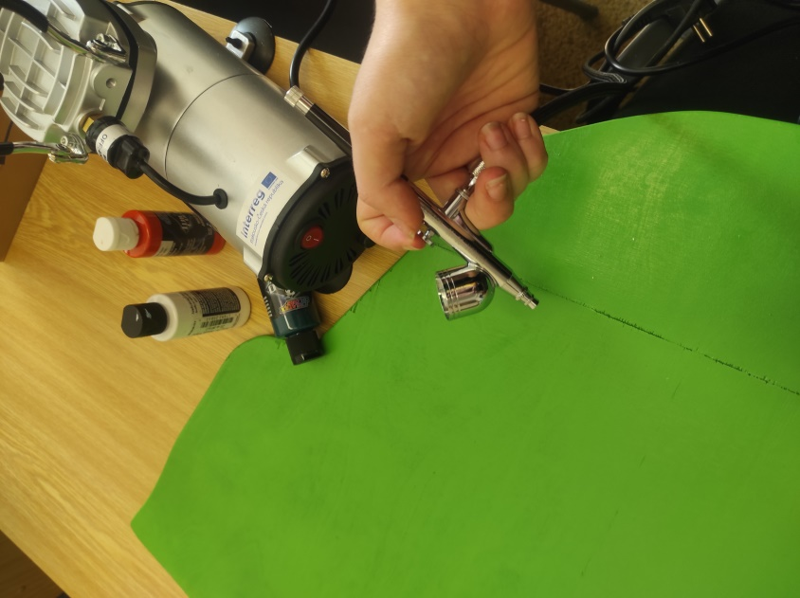

Roads, parking lots
The construction of roads and parking areas was among the most demanding. All roads, paths and water surfaces were modelled in Blender
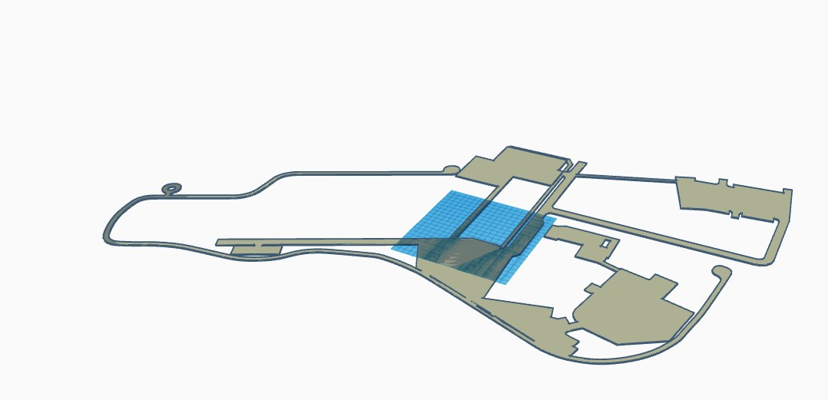
Tennis courts with a running track were then modelled in the Tinkercad program

Due to their size, it was necessary to divide the whole into smaller sections, which were then created in parts on a 3D printer. We used PLA filaments for printing in all cases.
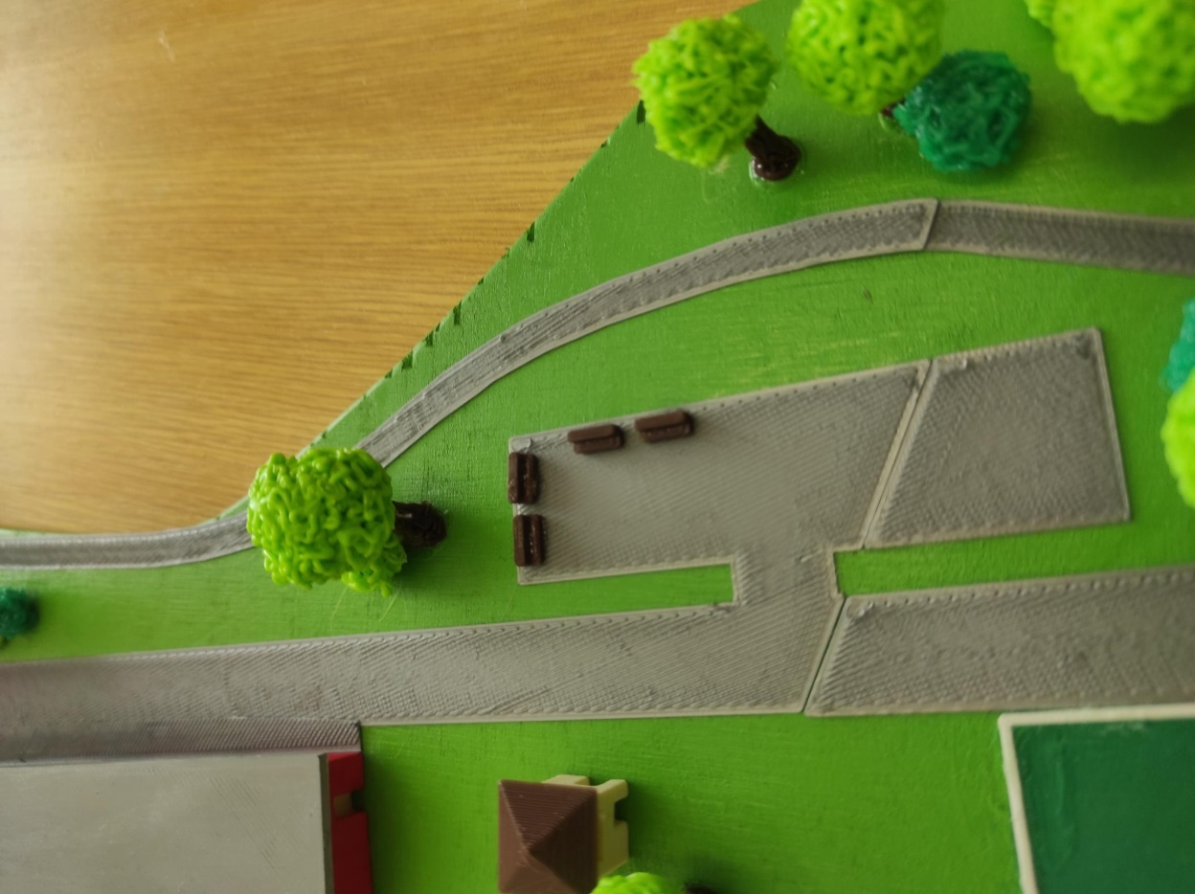

Winter stadium
Due to the large number of details, the hall of the current winter stadium was one of the other challenging parts of the project.

Here, Daniel had to use the blending of several types of basic shapes. Then remove the doors and windows from the building.

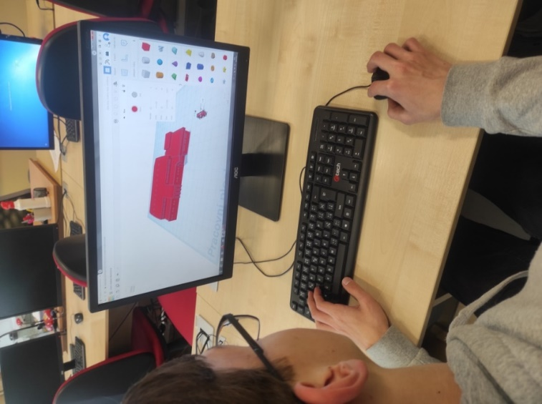

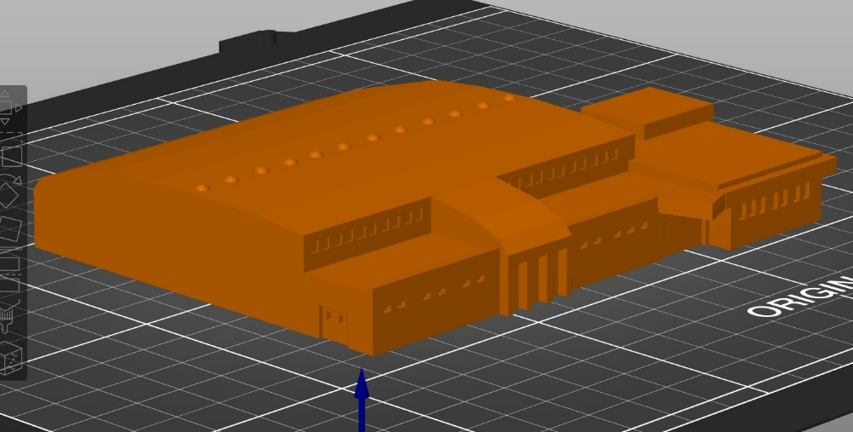

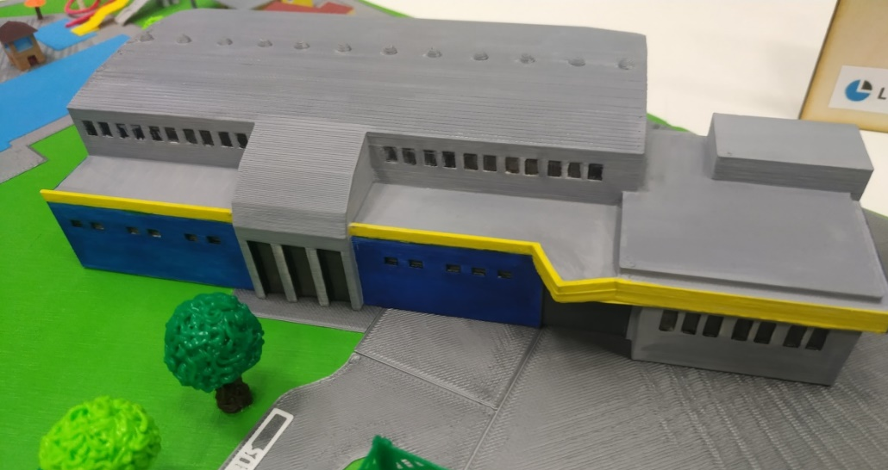

Swimming pool "Červenka"
The swimming pool area consists of several buildings and objects - such as entrance buildings, changing rooms or toilets. This also includes smaller ones - parasols or perhaps benches. Probably the most difficult was the toboggan.

Entrance building
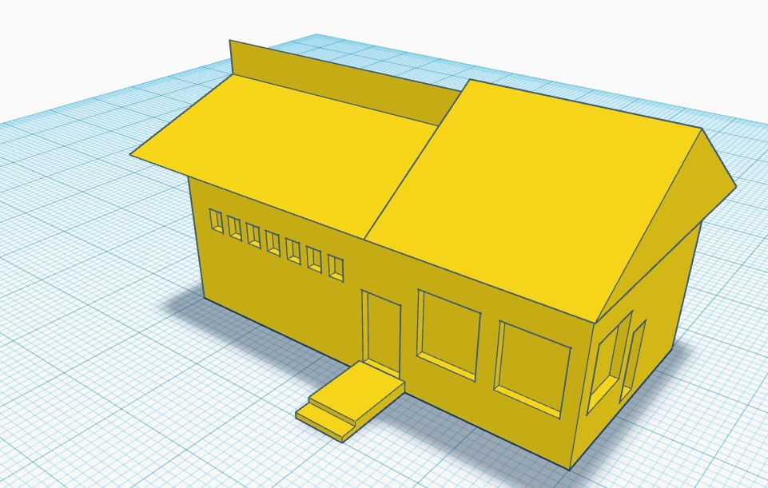

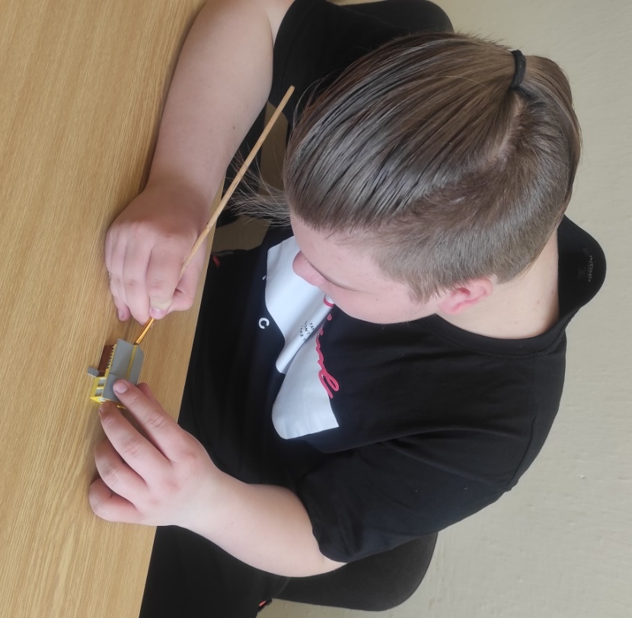

Colour adjustments by Adam

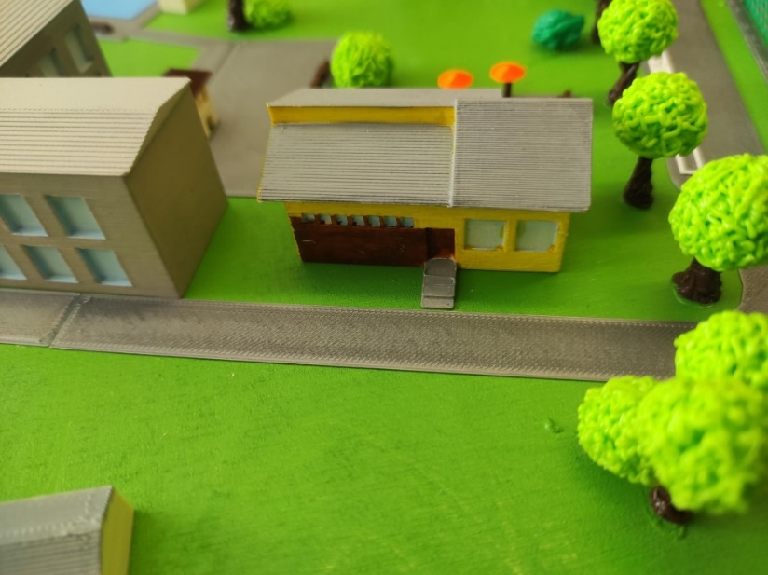

Locker rooms

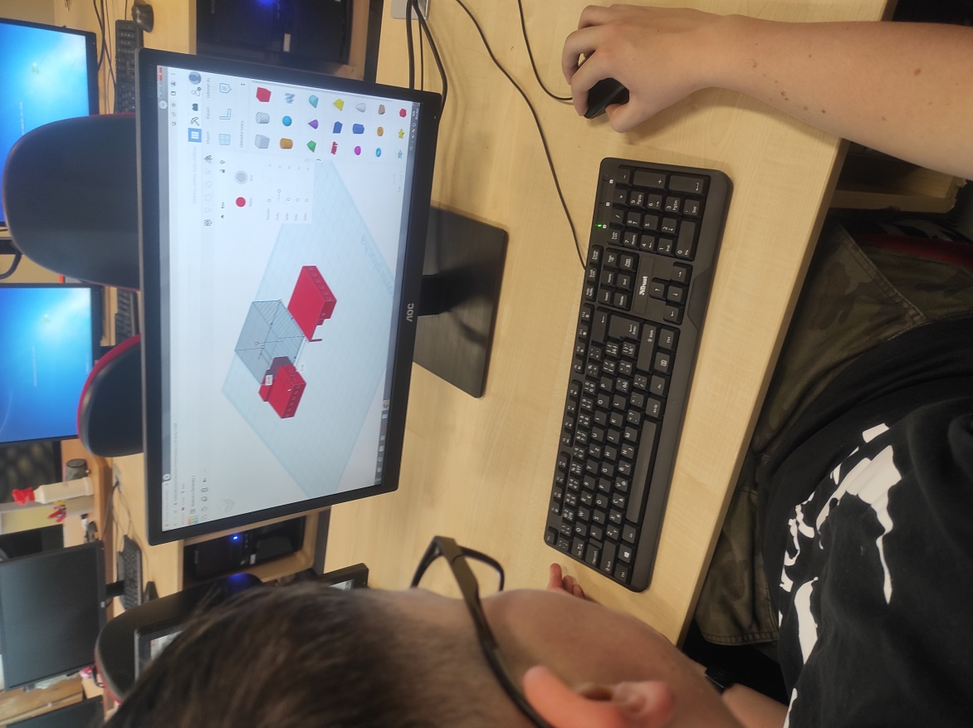
Due to the problematic placement of the supports during 3D printing, one of the dressing rooms was designed in reverse in Tinkercad.

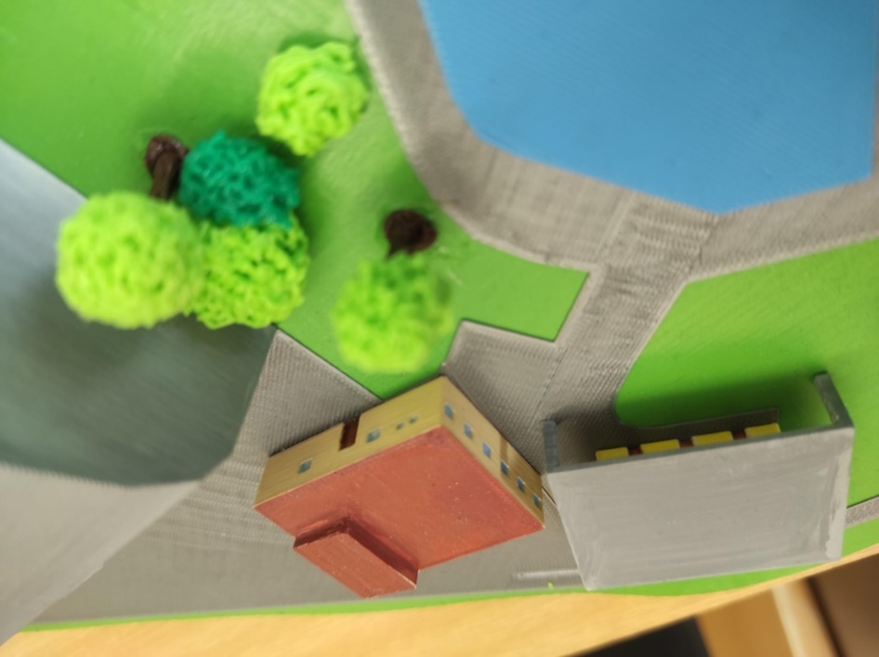
The resulting form

Toilets, umbrellas, benches

Colour treatment of toilets

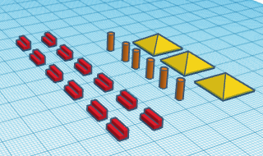
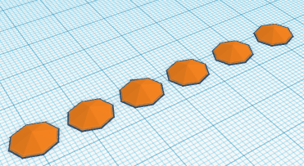
Parasols, benches

The resulting form

Changing rooms

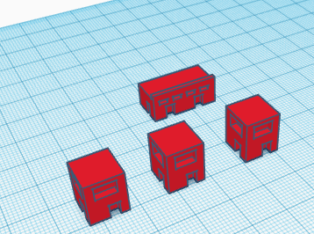
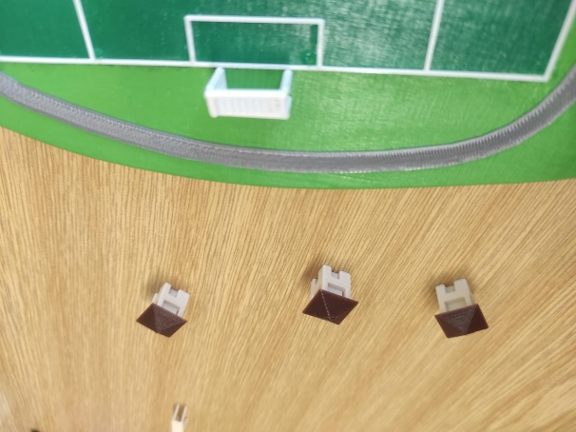

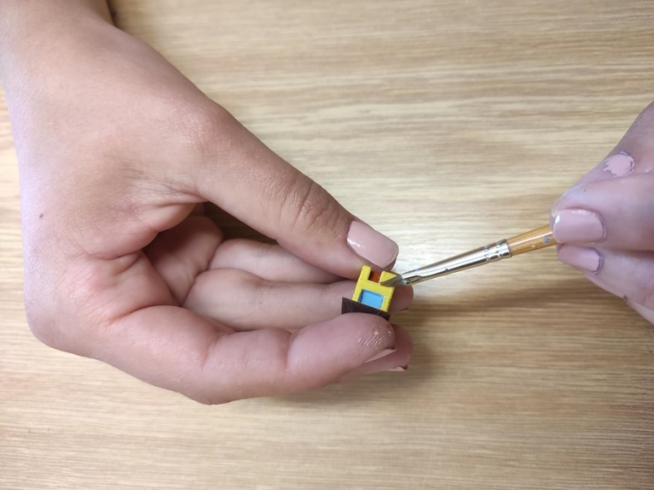
Again created in Tinkercad and then colored in – each differently for originality

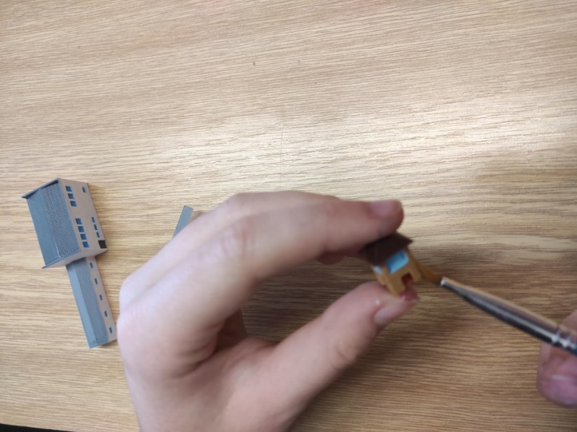

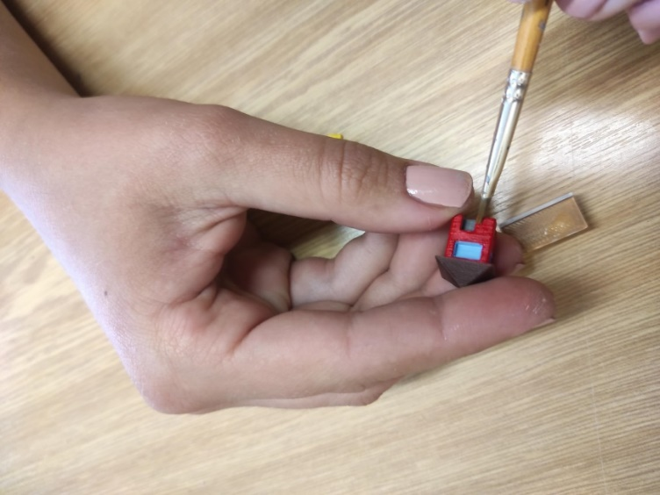

Water slide
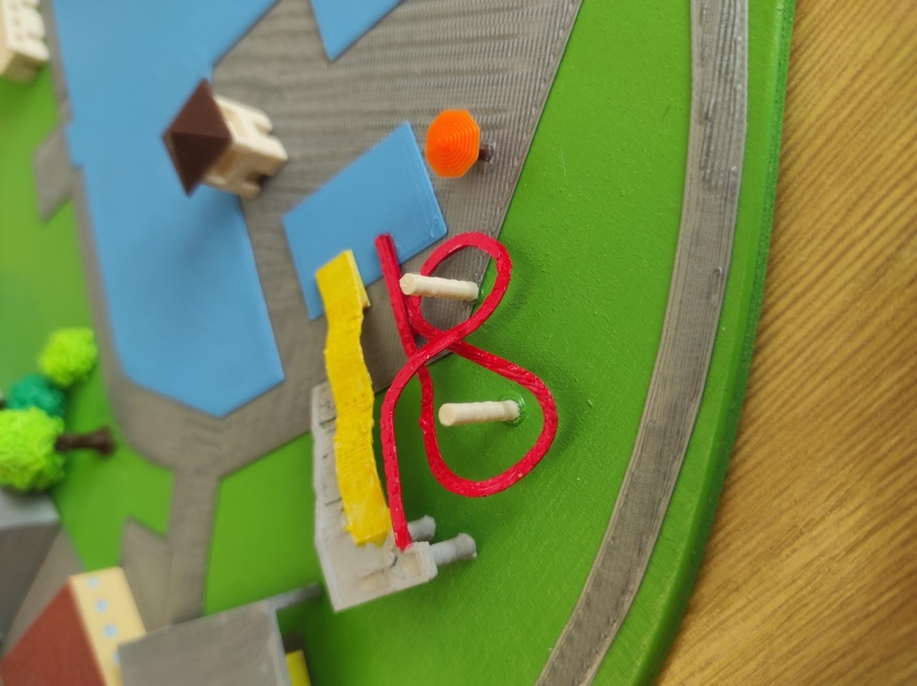
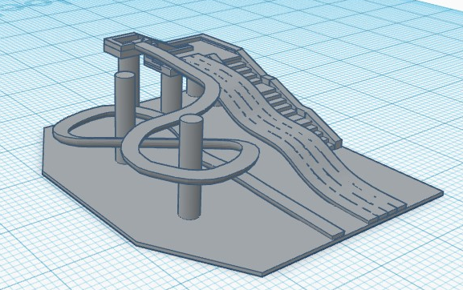

Due to the complexity of the slide, it was necessary to divide the entire object into smaller sections and print each one separately.

The resulting location

Bridge over the water

We created the footbridge in Tinkercad.

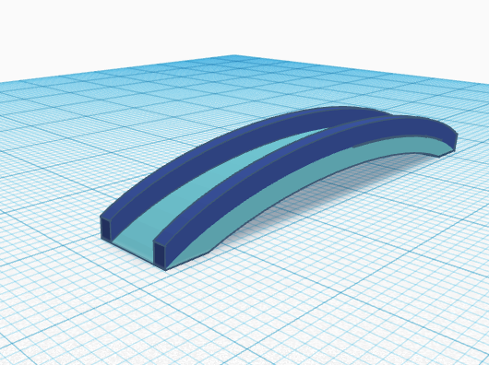

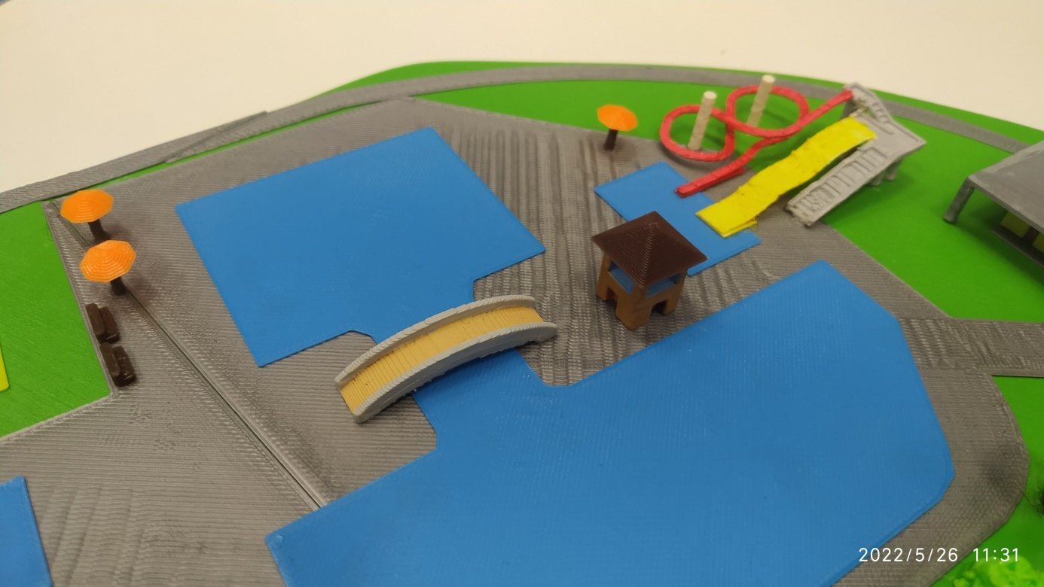

Aquapark

One of the easier jobs was the creation of the water surface of the swimming pool. It was created in Blender.

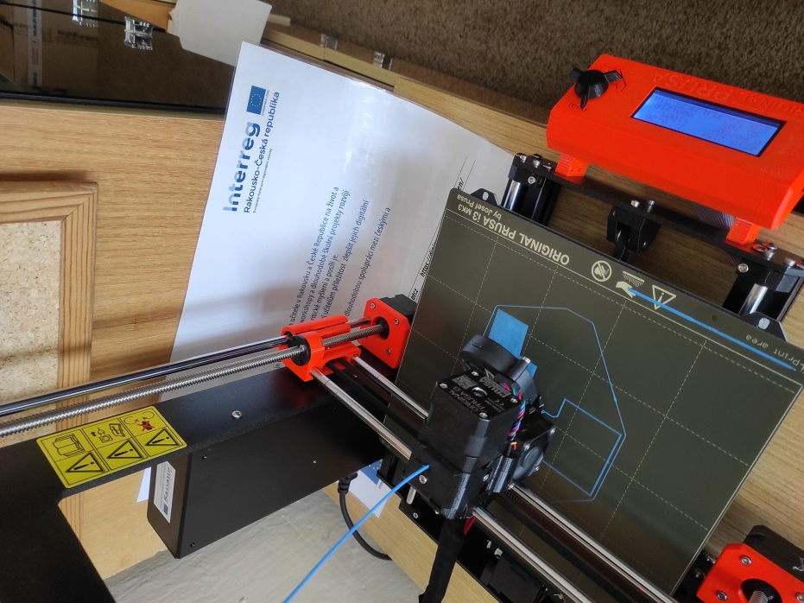

The resulting image with a toboggan and other details

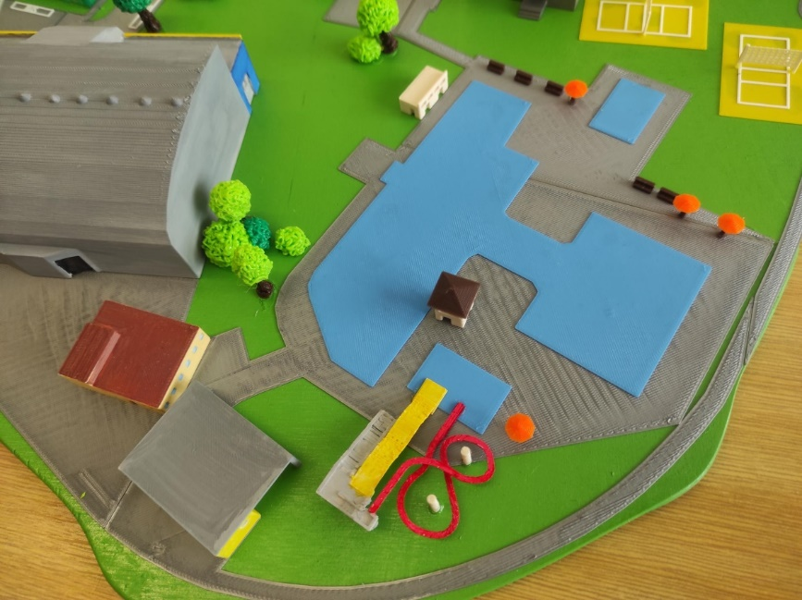

Wastewater treatment plant

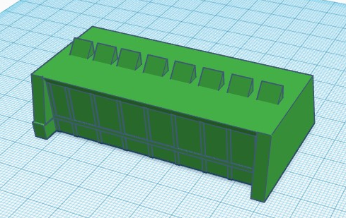

Final dyeing of the cleaner by Kamila

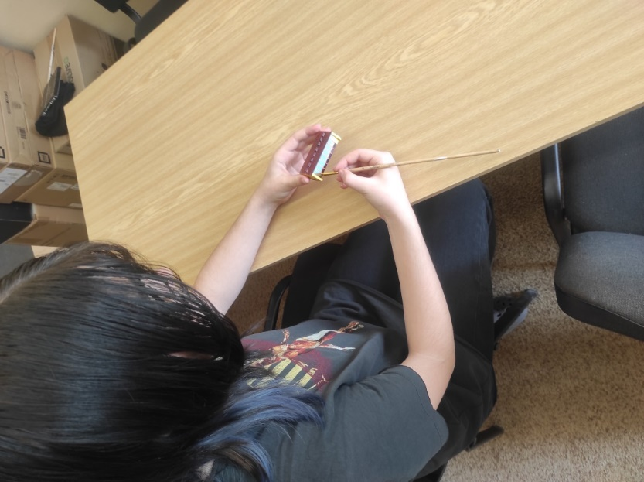

The resulting placement on the board.

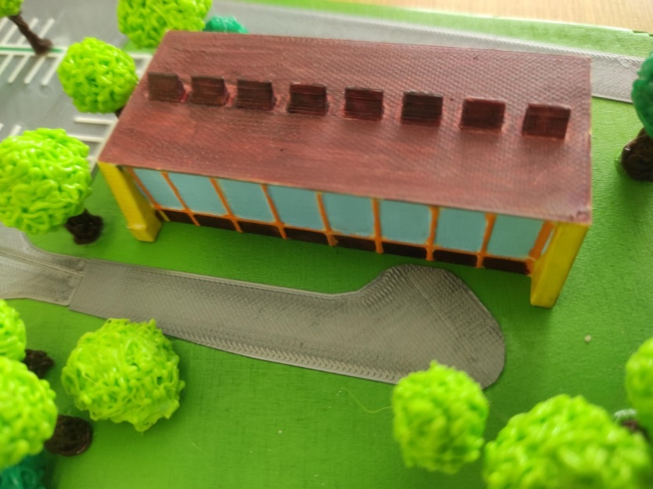

Multipurpose hall

The biggest organisational (non-technical) problem, as explained in the introduction, is the new hall and its appearance. To this day, it is not entirely clear what it will look like. We chose one of the options. After the final form is closed, it will be replaced with the real one in the model.
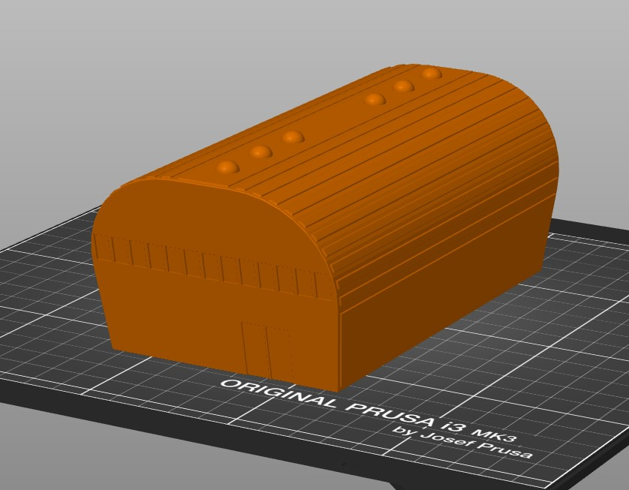

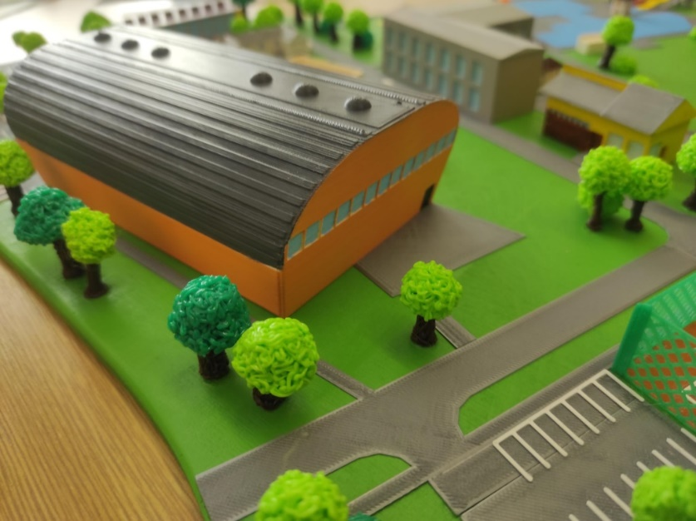

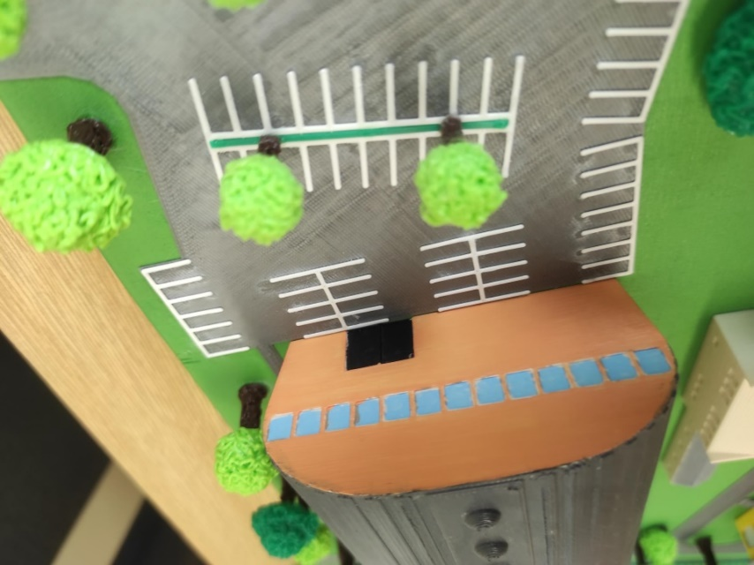

Athletic oval

When printing the oval, we again had to divide it into 3 parts and print each one separately.

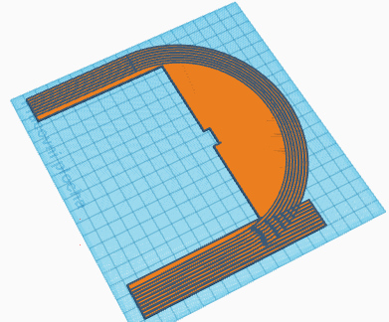

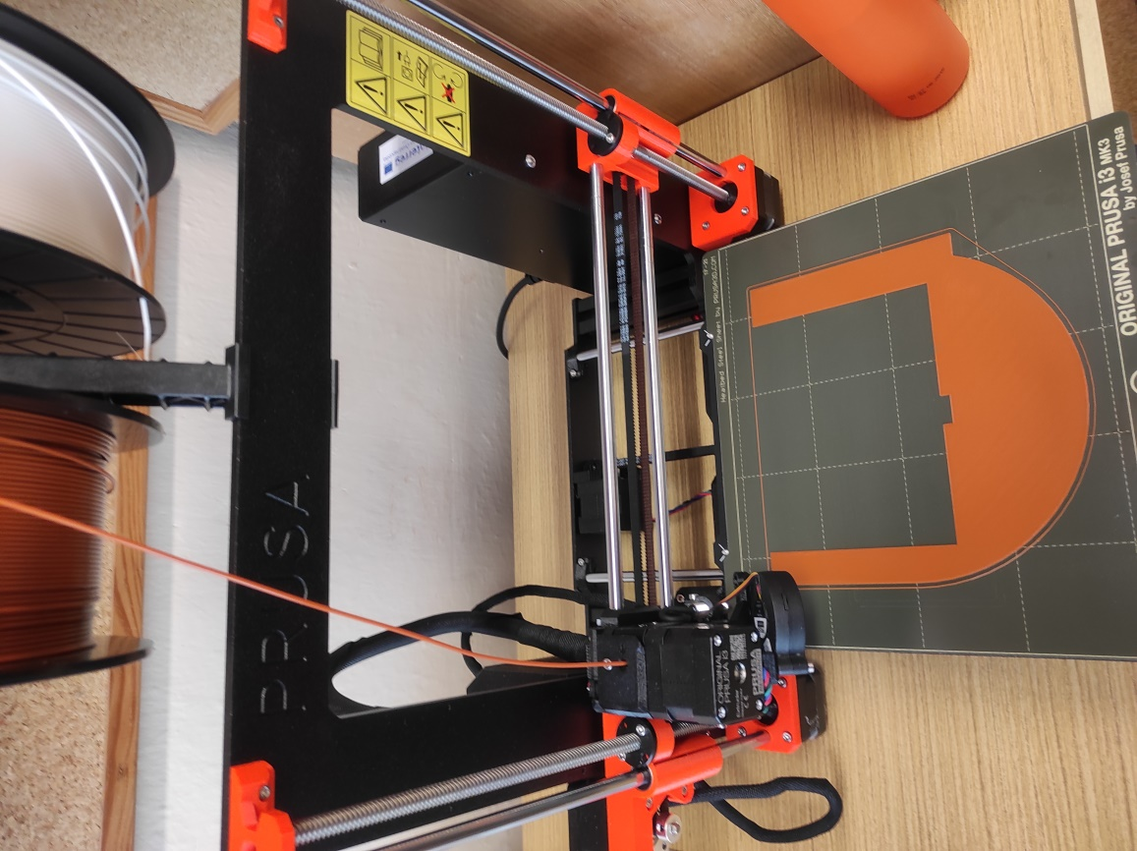

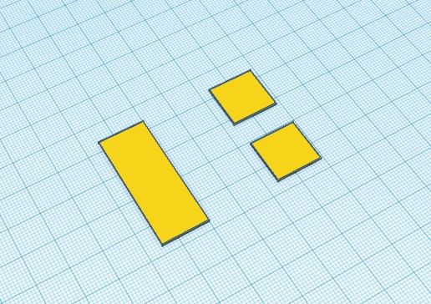
sandbox

Football stadium

Flat
In TinkerCad we made only the "lines" for both stadiums, the inner part of the field was sprayed with a paintbrush.
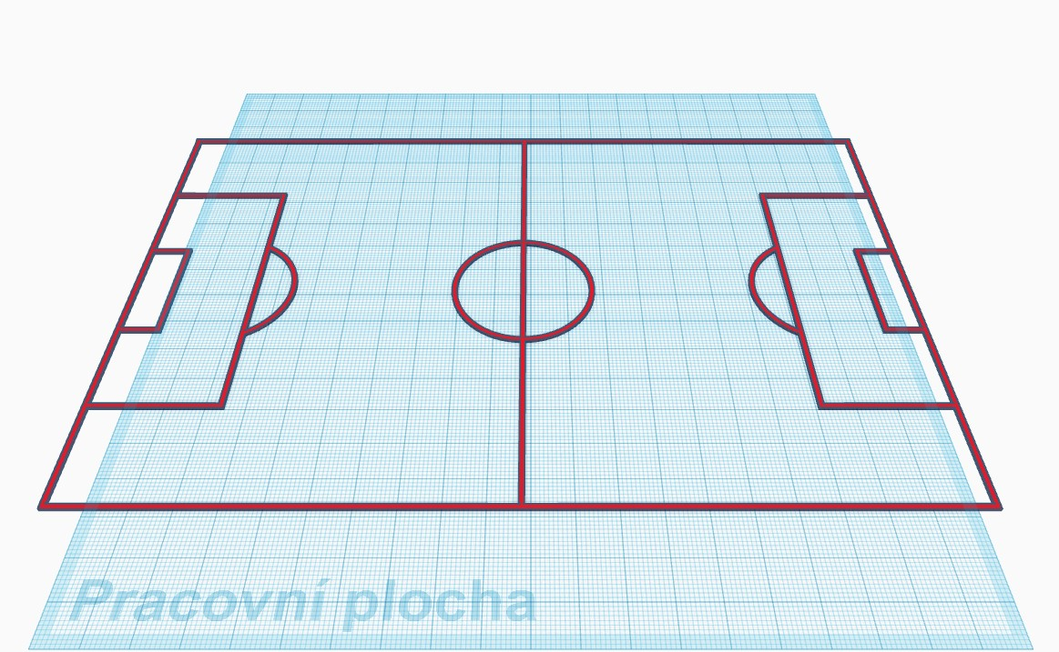

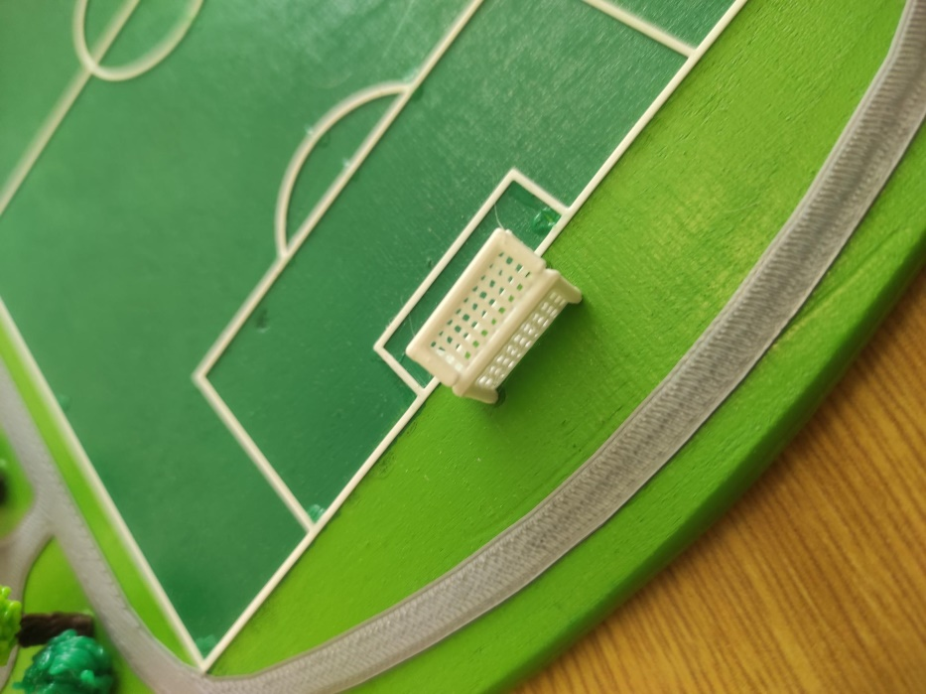

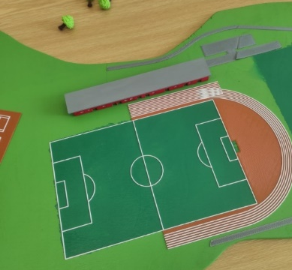

Football locker rooms

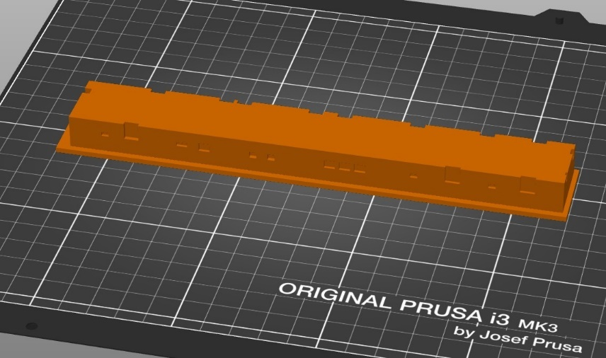

Kamila draws the details

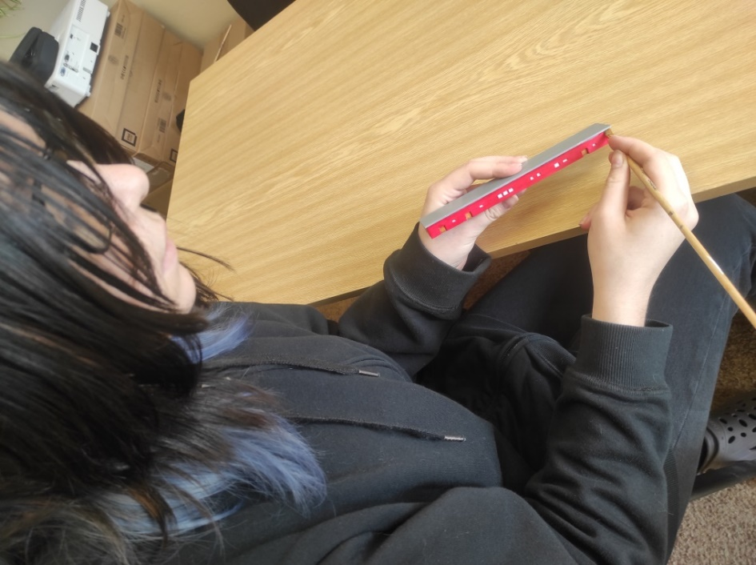

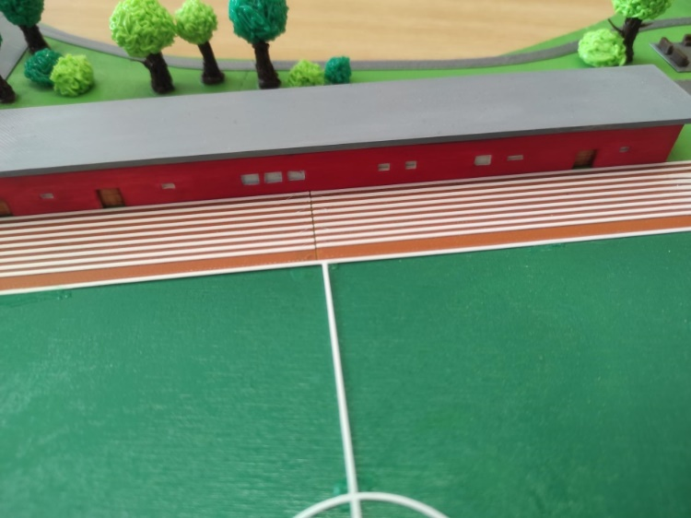
The resulting form

Football stadium accessories

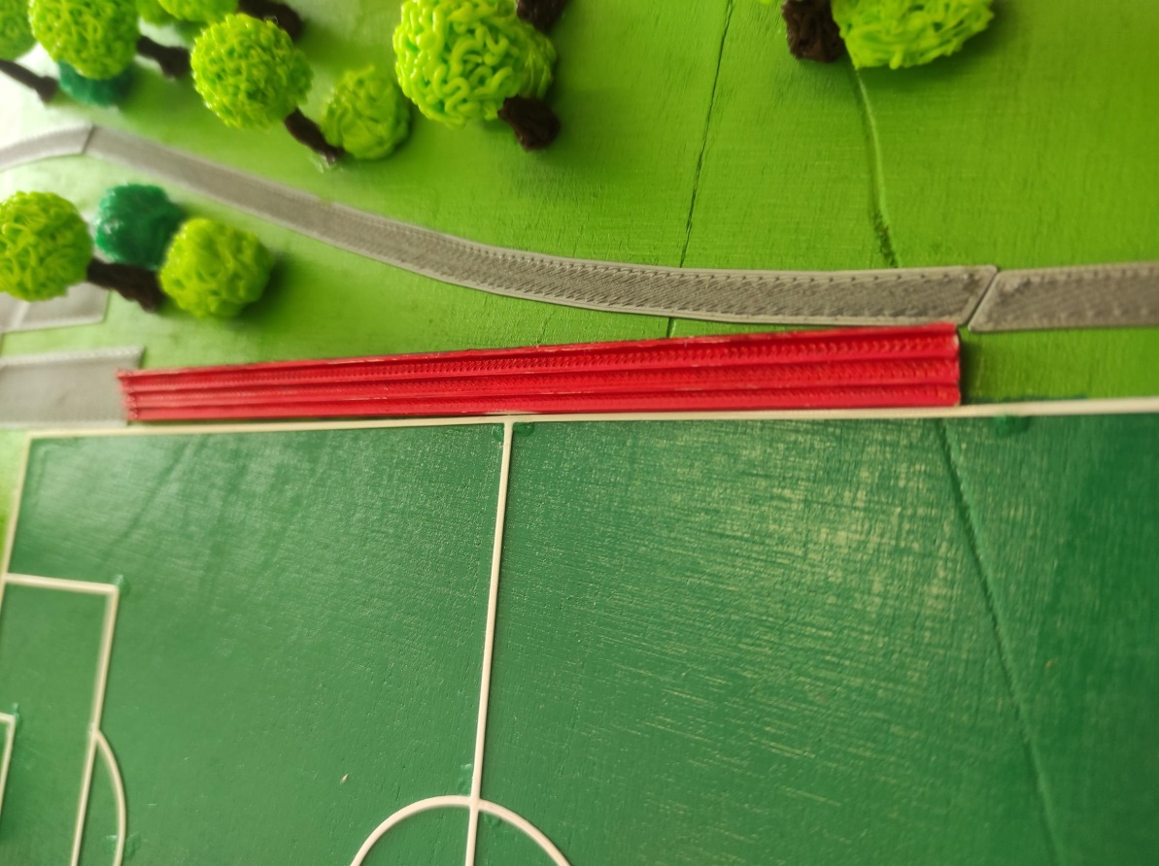
Grandstands for visitors

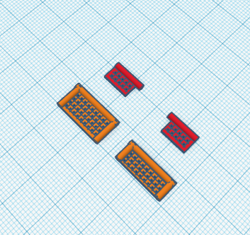
Soccer goals
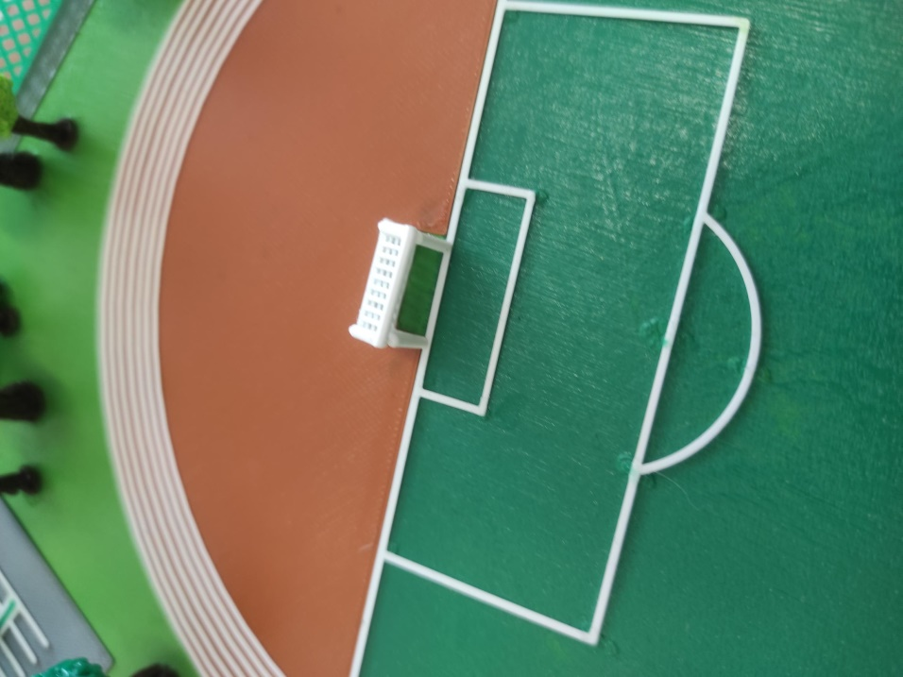

Administrative building
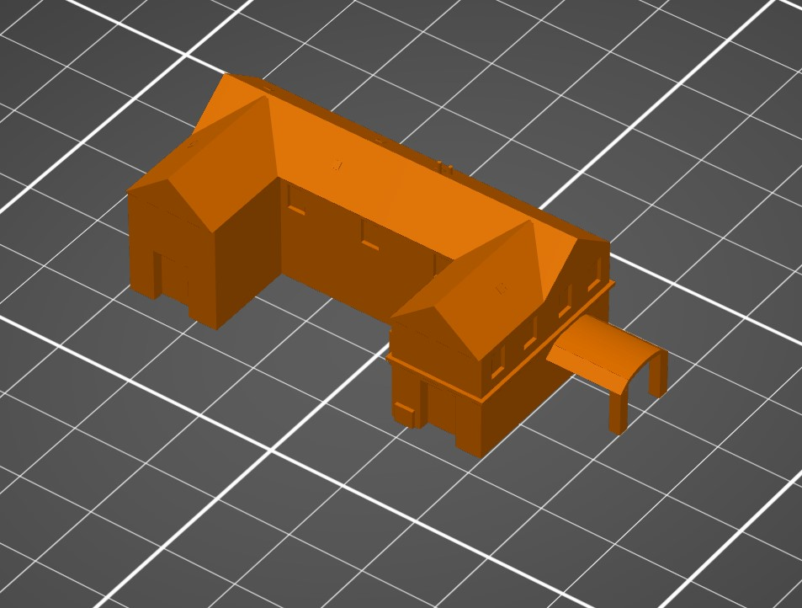

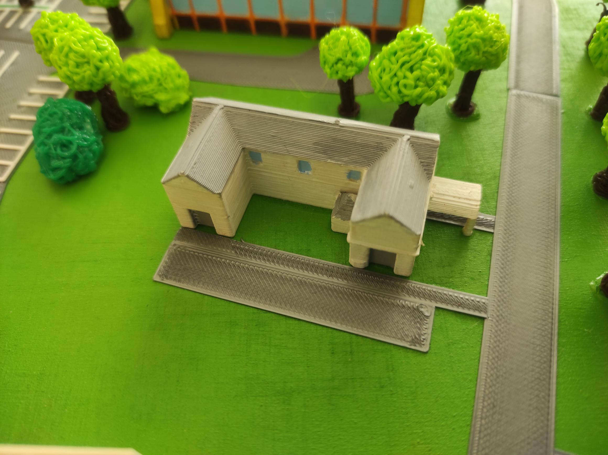

Bowling alley
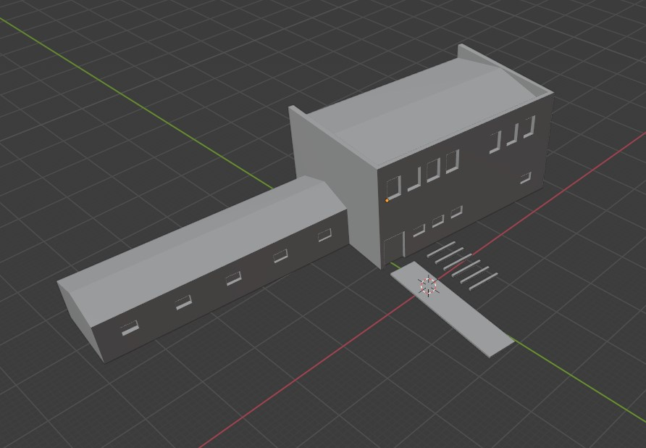

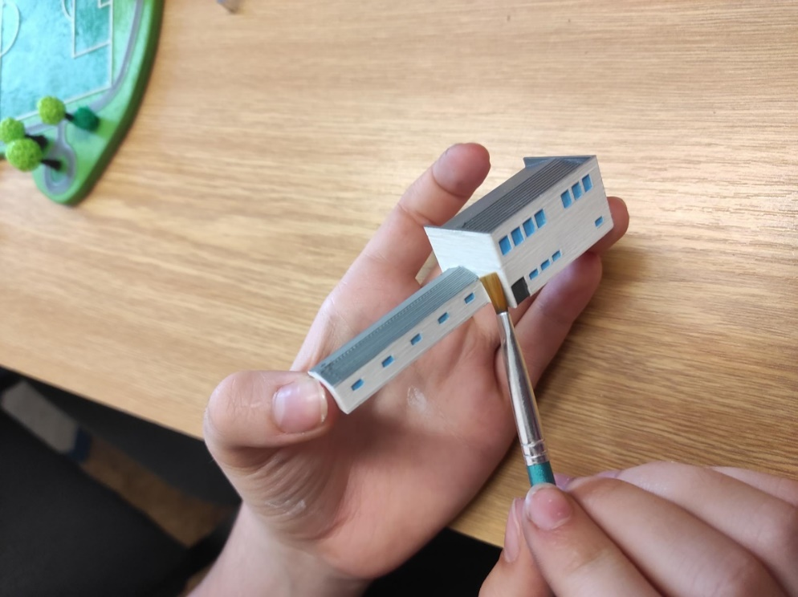

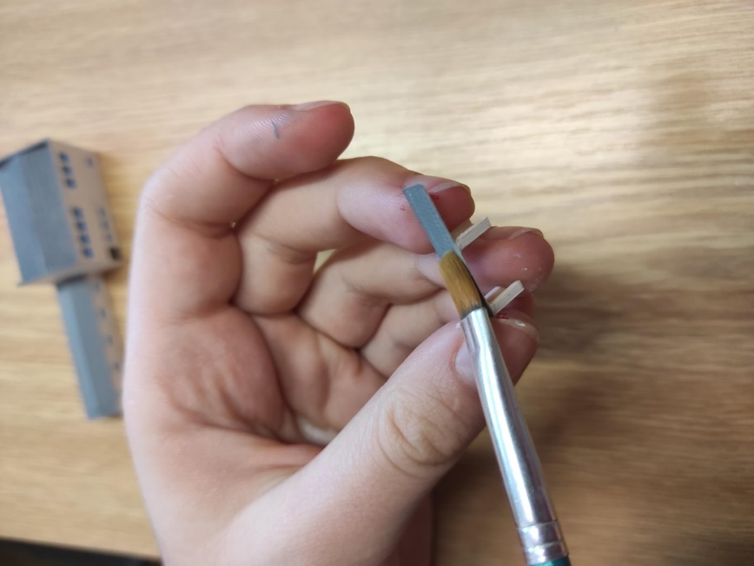

Hostel
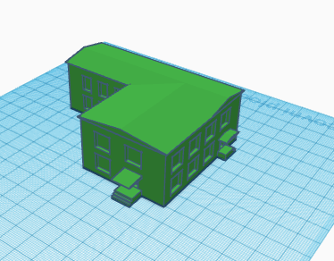

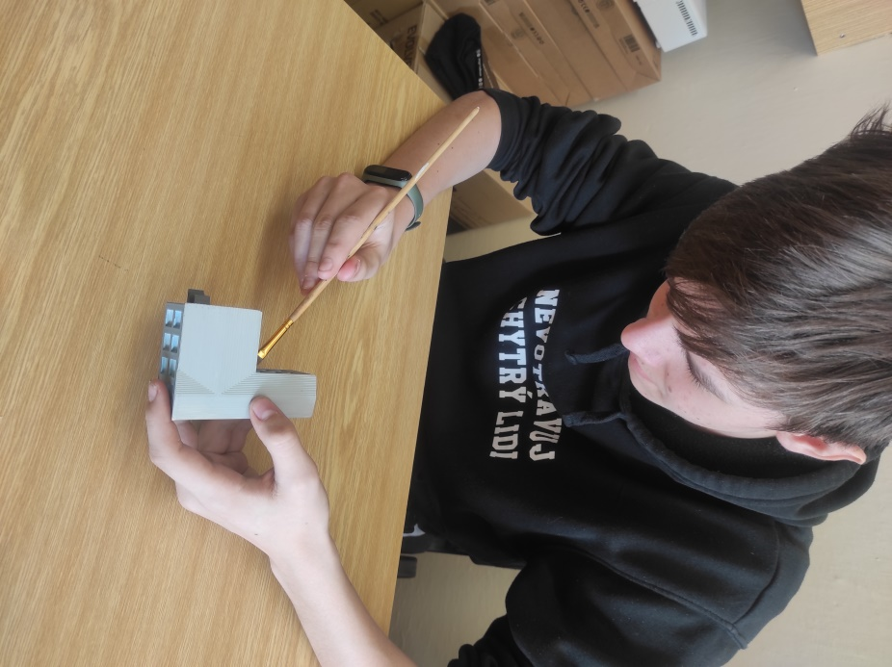

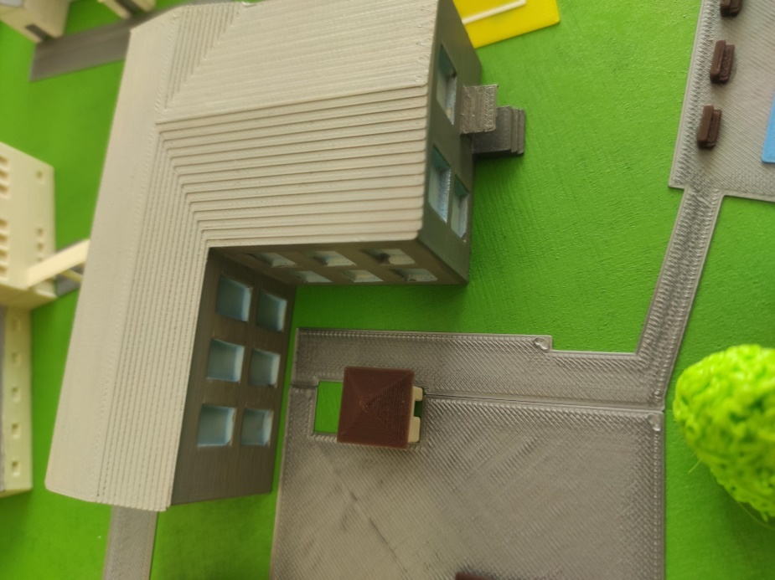

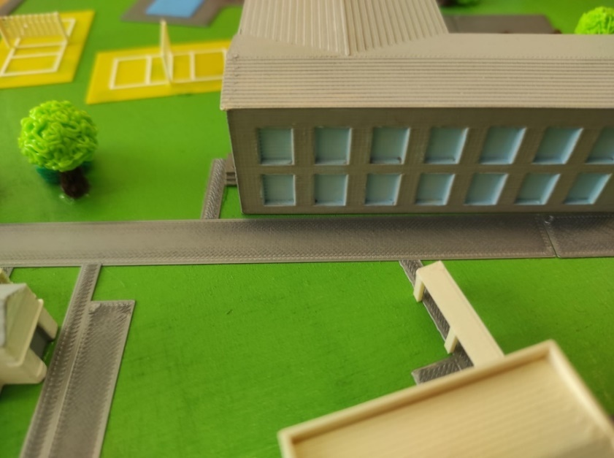

Substation

One of the simpler object models is a substation
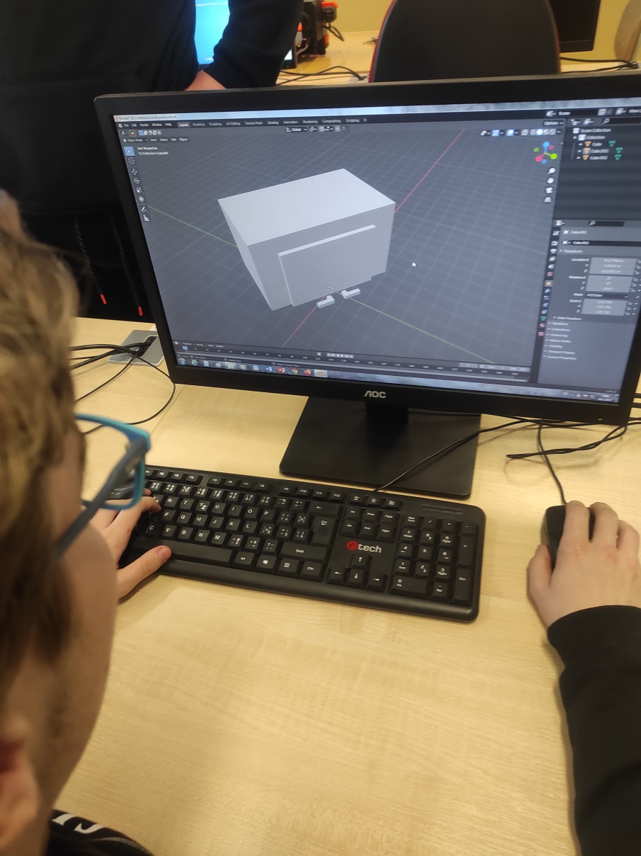

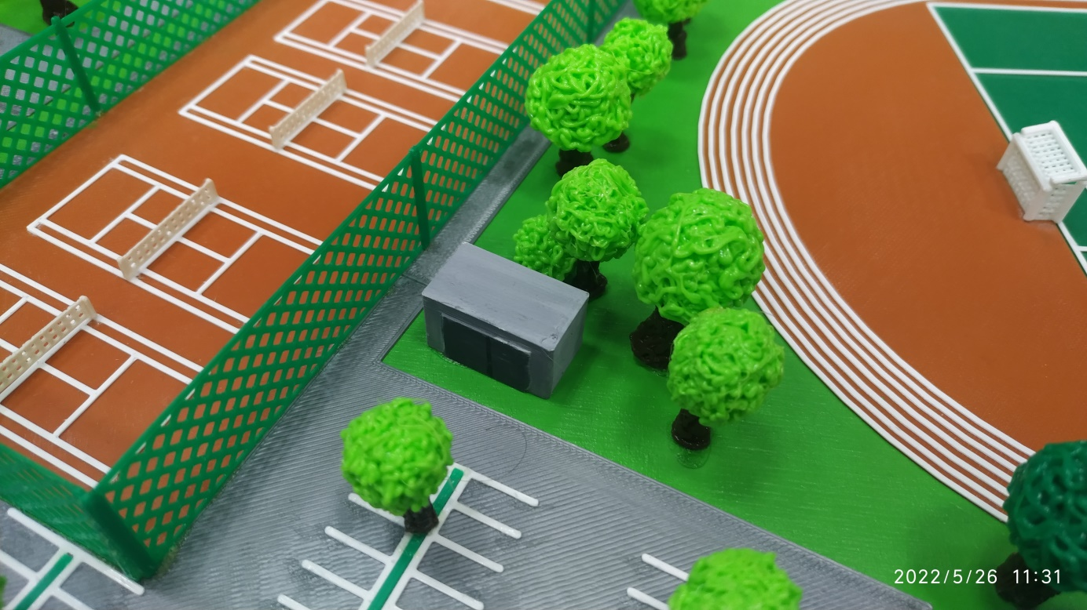

Volleyball courts
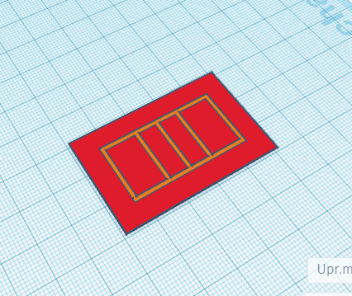

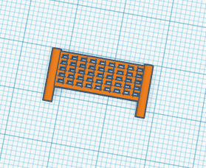

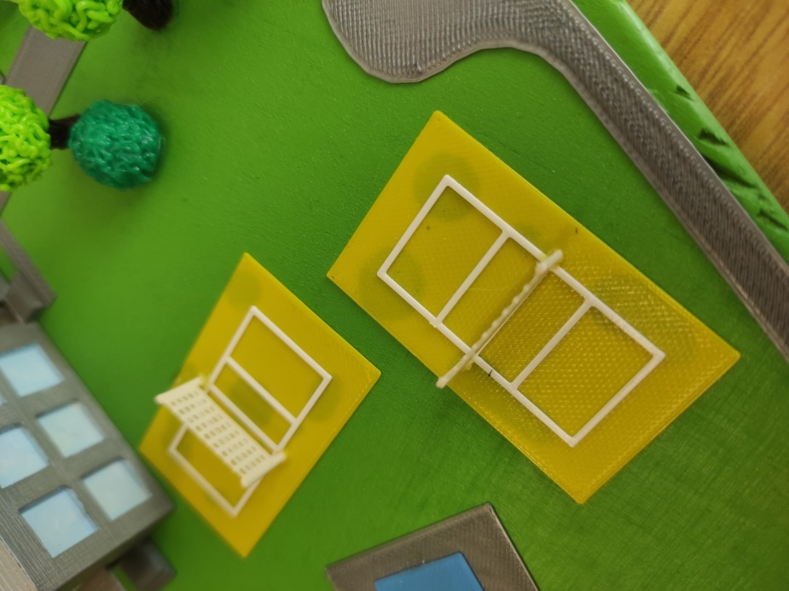
For the creation of volleyball courts, we chose a similar procedure as for the football field. Only with the difference that we also created the background and "lines" on it in the Tinkercad online program. Everything is then printed in 3D printing. For this, we completed the networks.

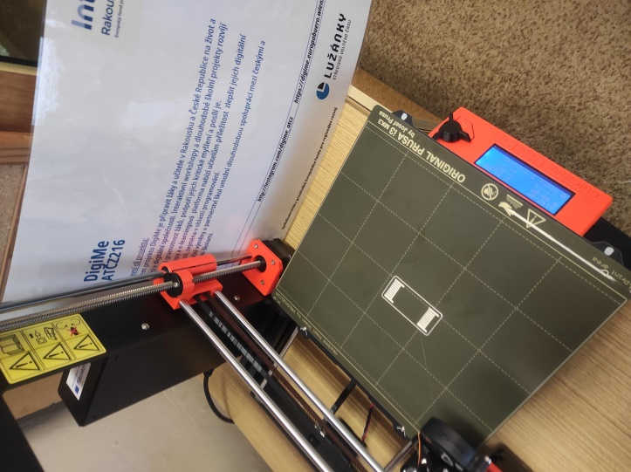

Tennis courts

Again the same procedure as for volleyball courts.
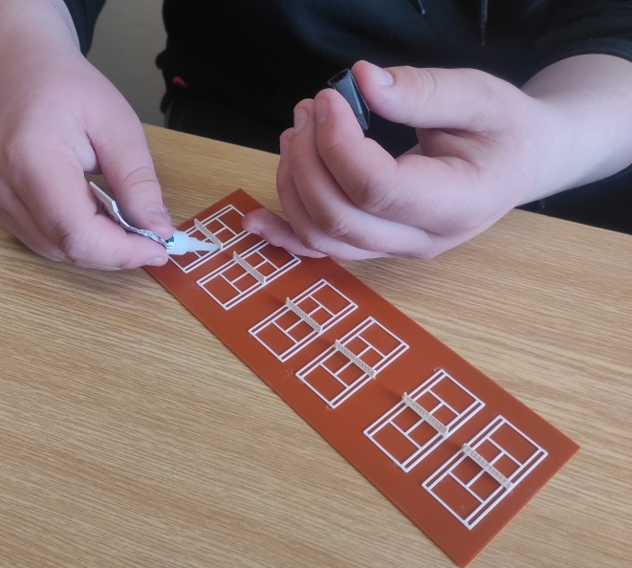

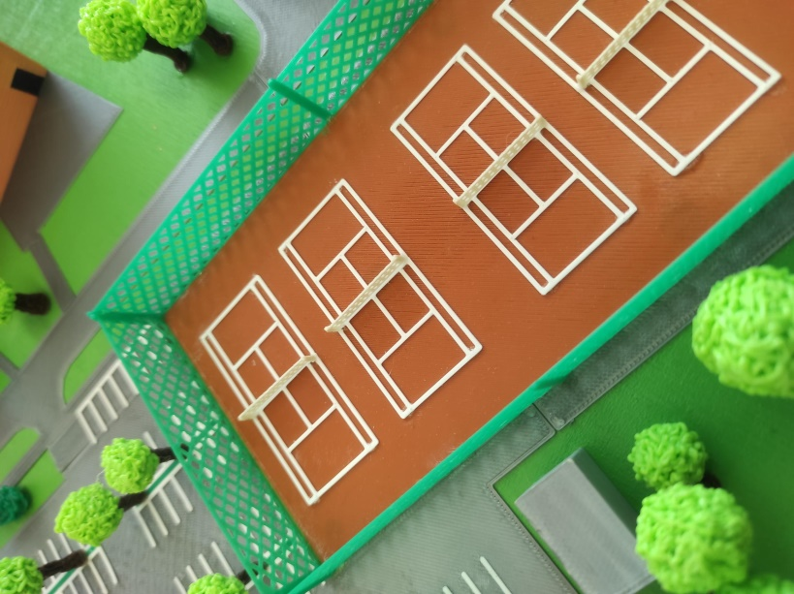

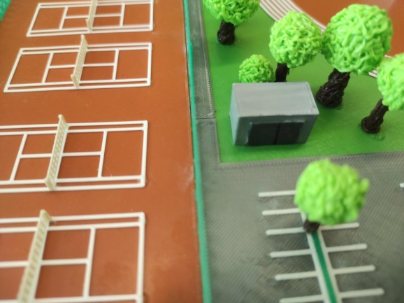

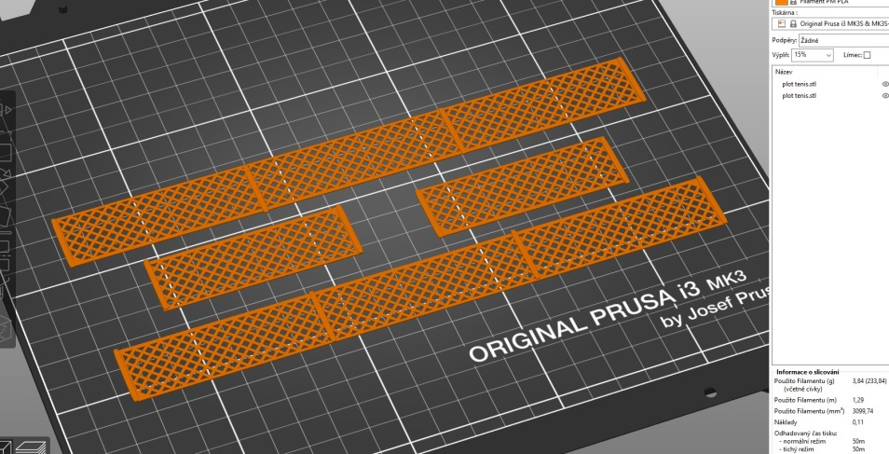

Printing of raised fences around the courts

Parking
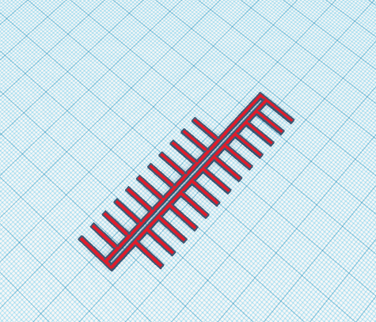

Printing of parking spaces

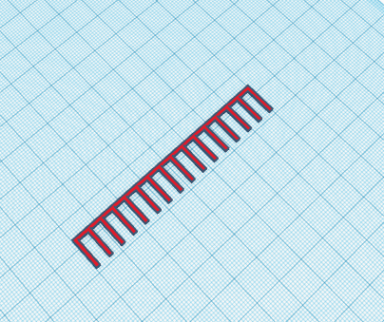

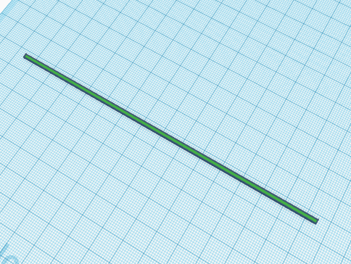
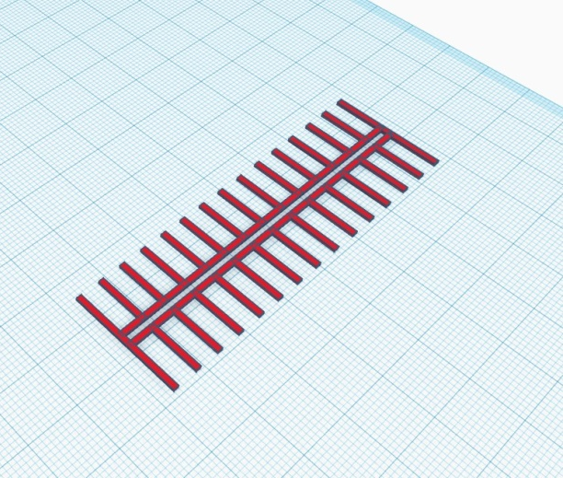

Printing pages as an addition to the parking lot

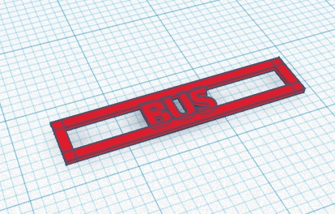

Bus stop printing

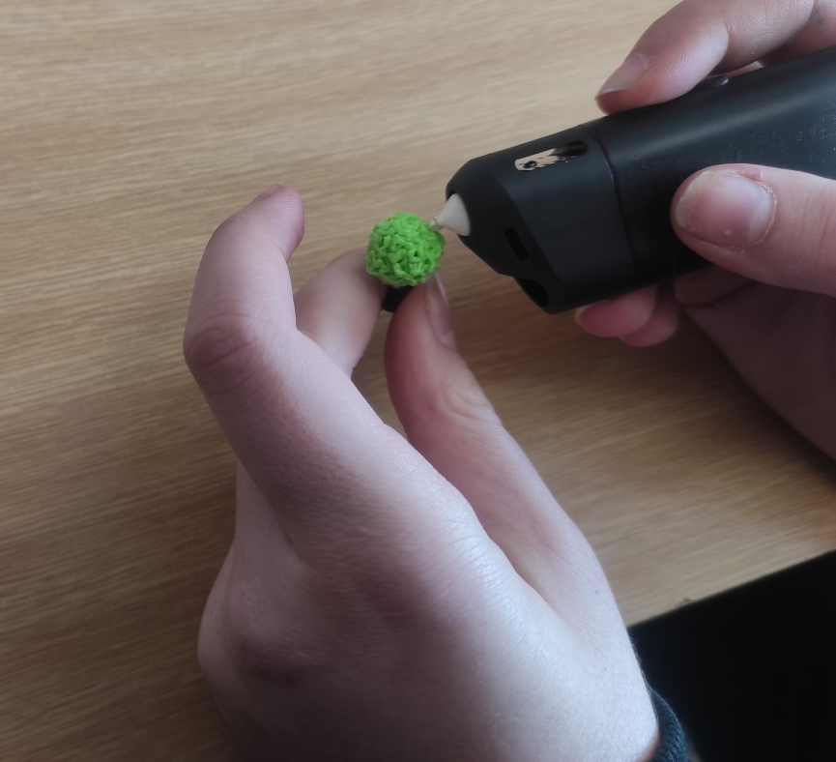
Nature
We used 3D pens to create living nature - trees and bushes. Each tree and bush is uniquely modelled by hand. A total of approximately 140 are planned.

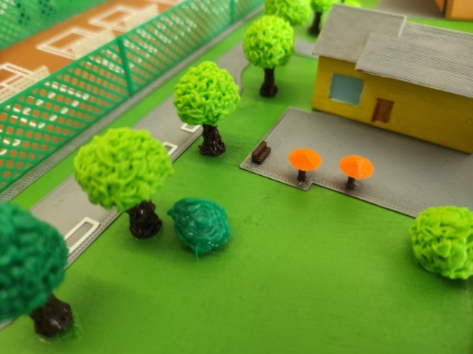
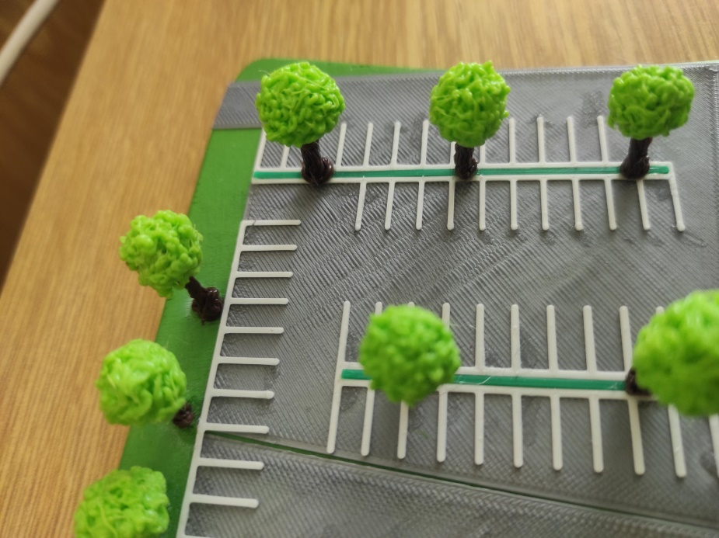

The resulting form
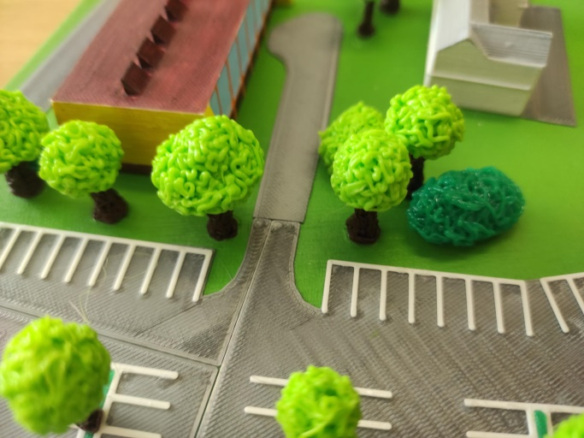

Completion of the model

After the completion of all buildings, objects, playgrounds, tracks, trees... we proceeded to complete the entire model of the future area

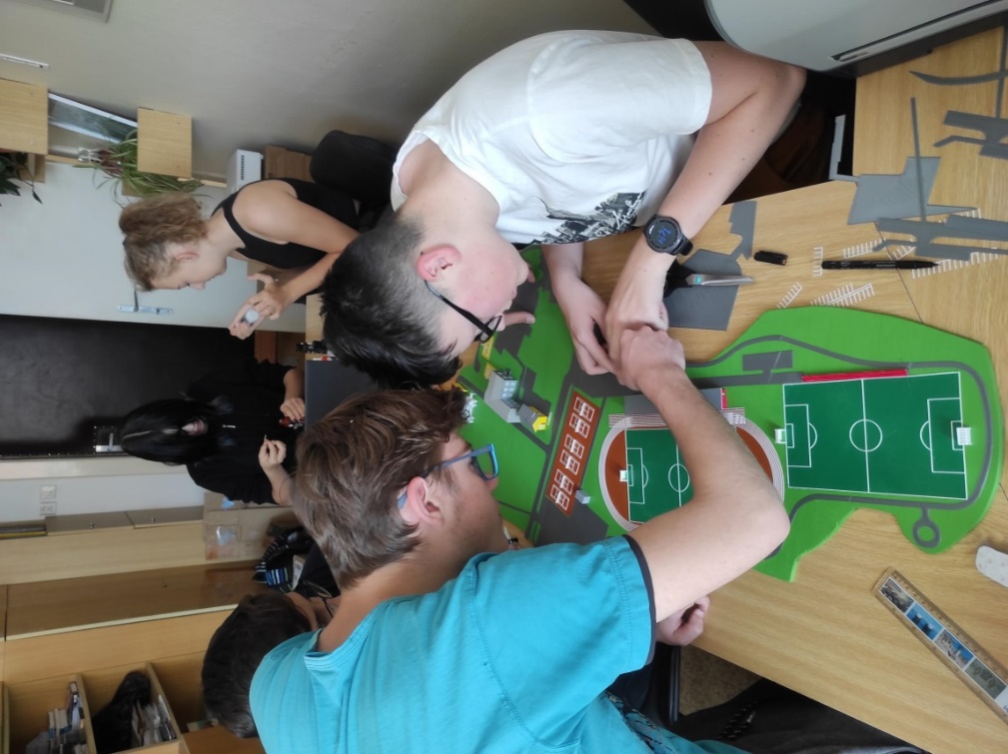

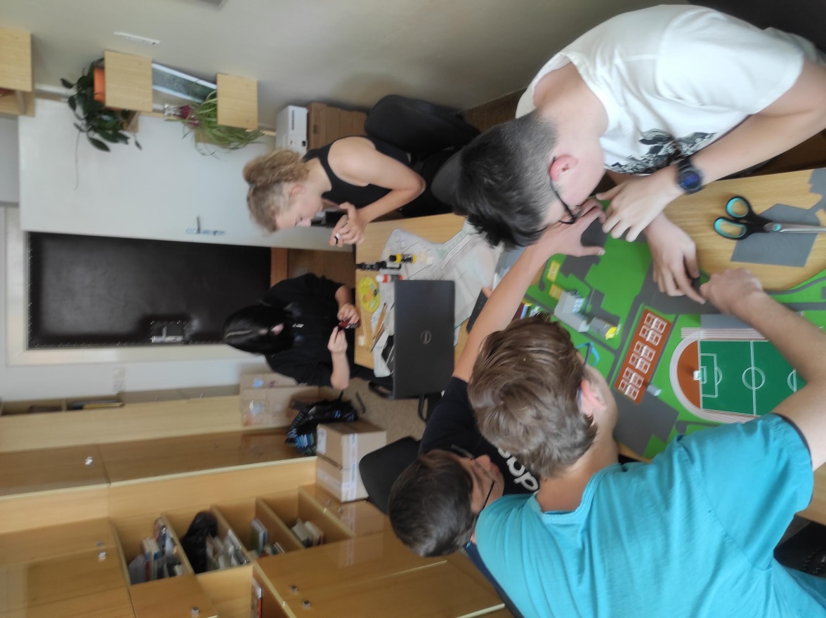
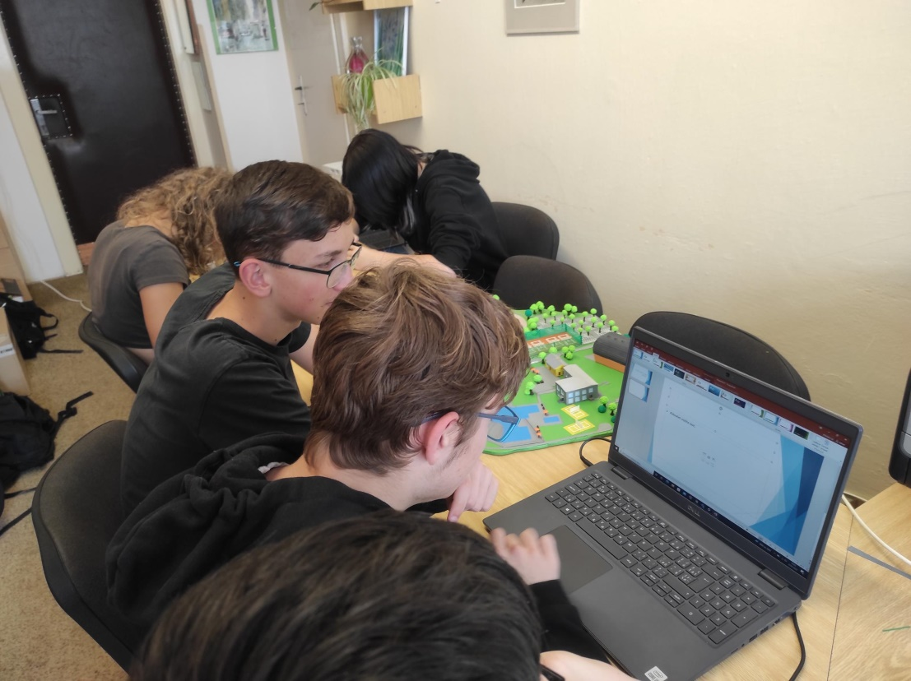

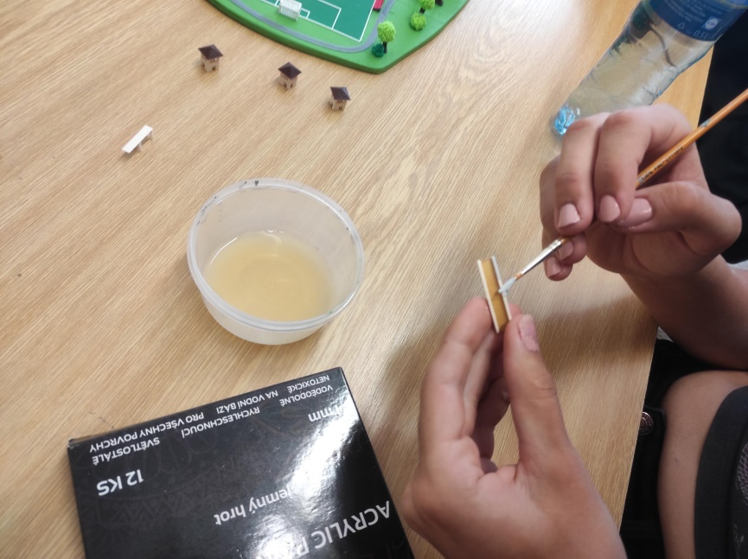

A table with the name of the project
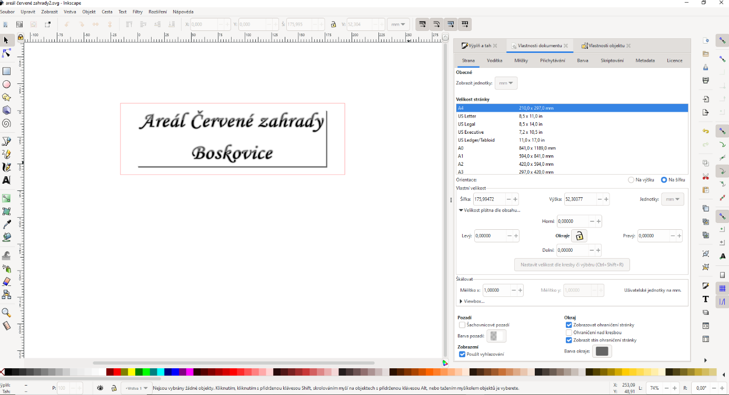
Finally, a demonstration of the use of the Laser plotter. We created a table in the inscape program

Using the K40 Whisperer program, we sent it to be engraved and laser cut

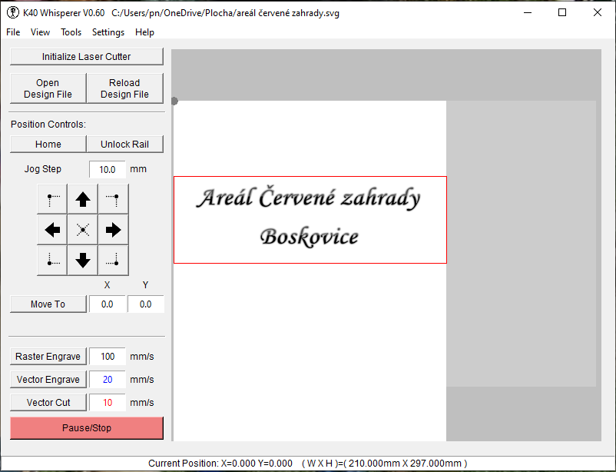

Engraving and cutting out the inscription

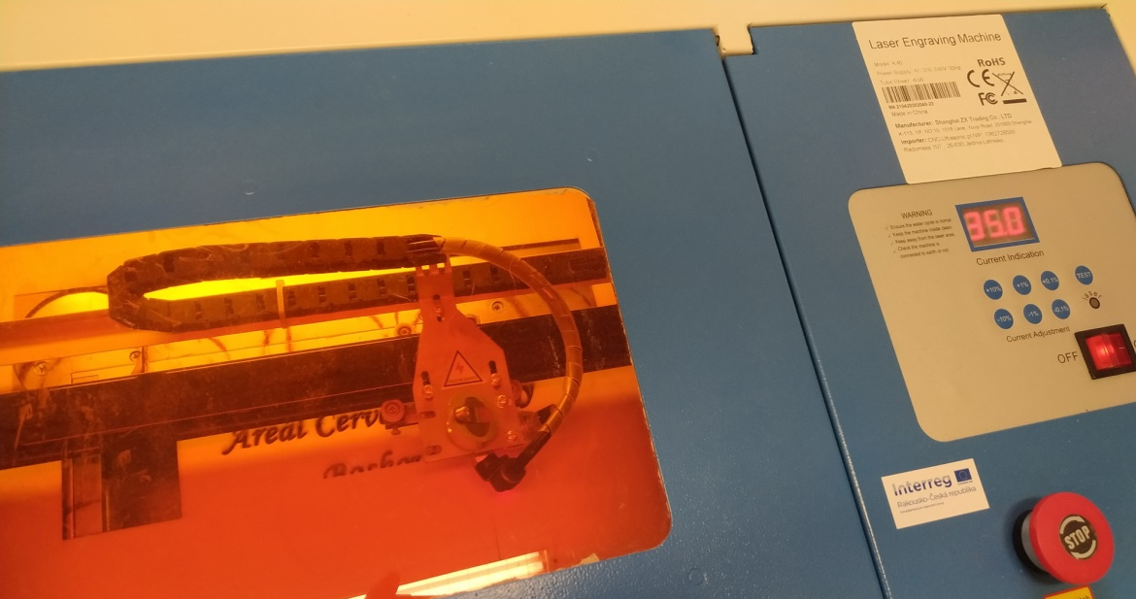

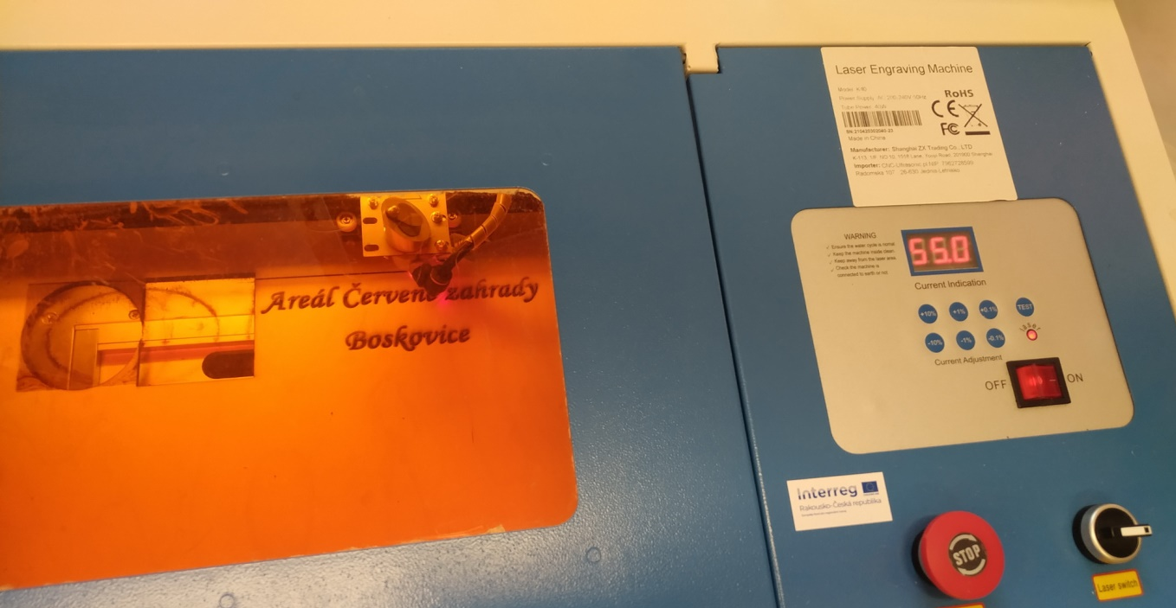

The resulting form

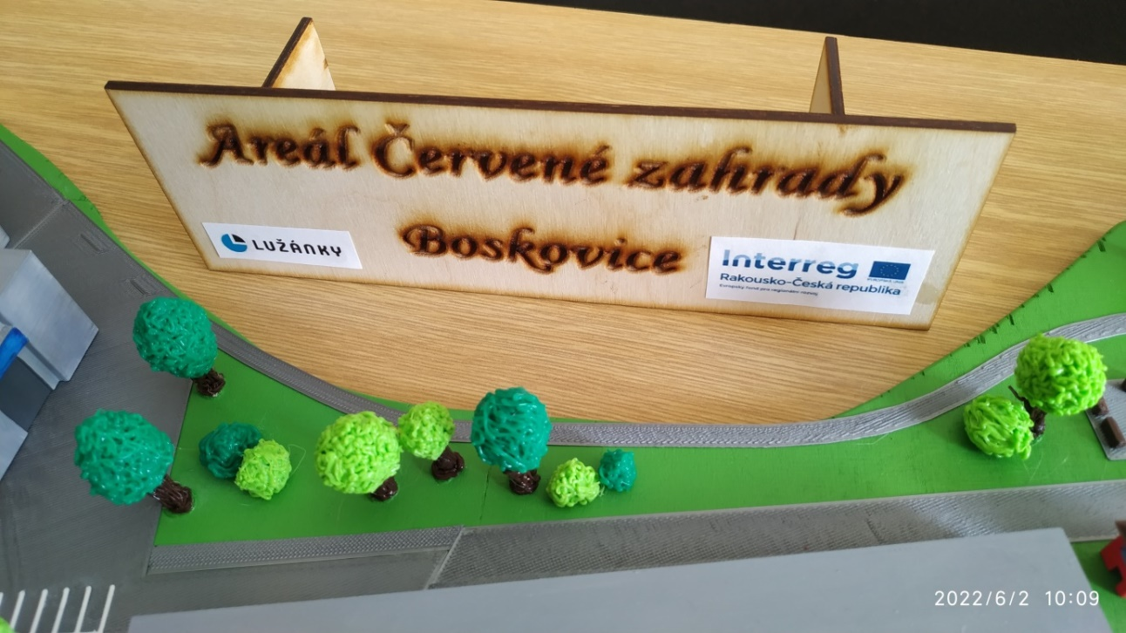

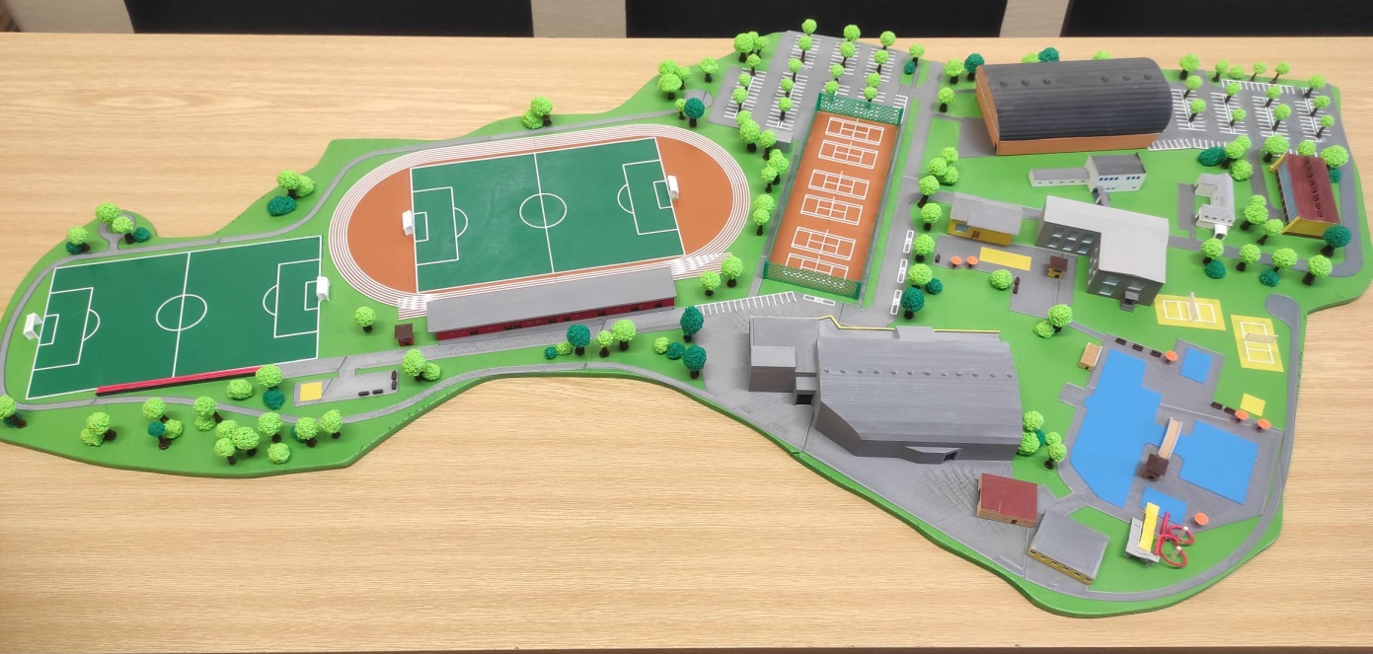
The final form of the project
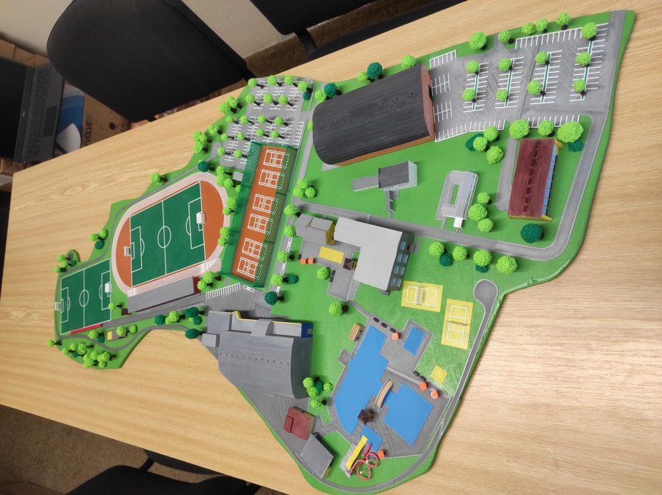
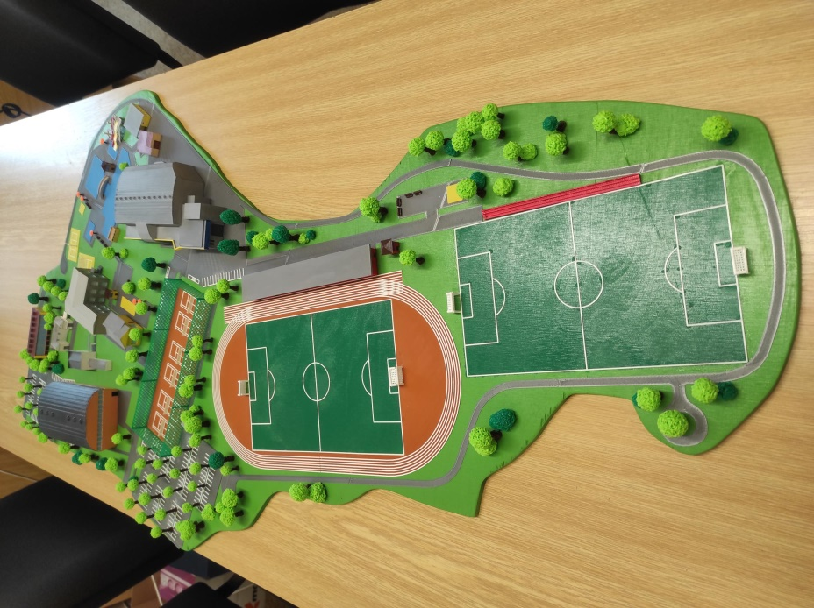

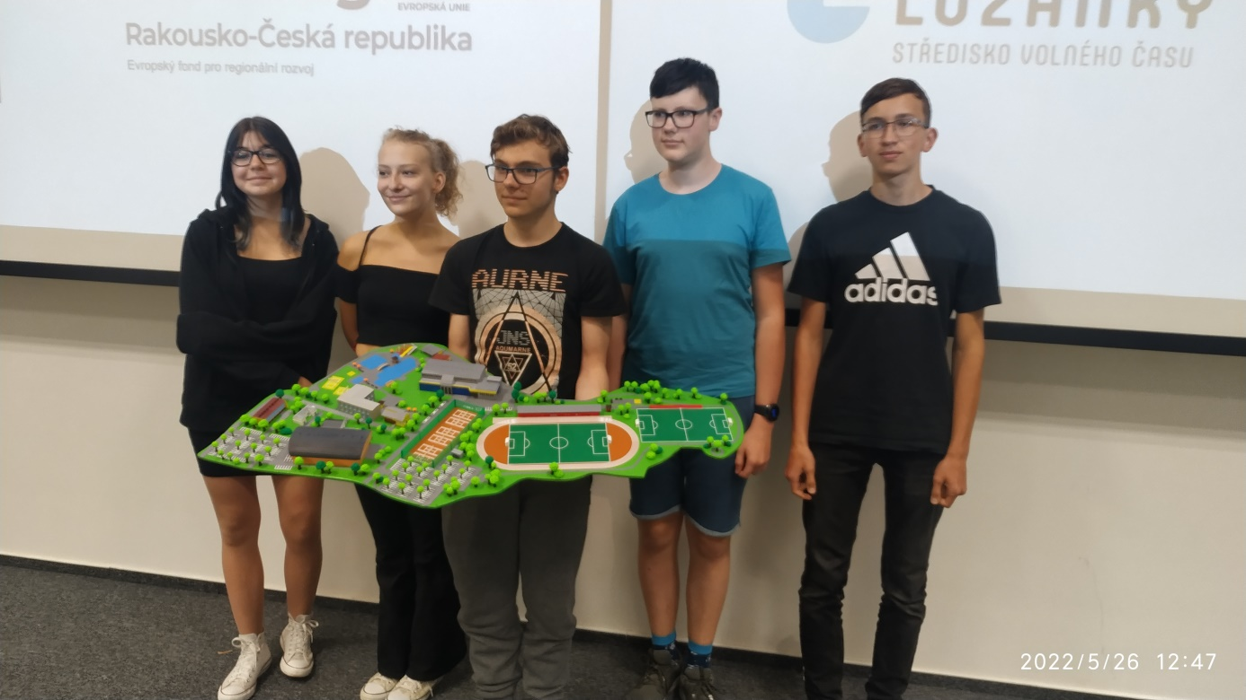
Competition on 5/26/2022 in VIDA

It was not a victory, but that does not stop us from continuing not only to complete the model according to the final version of the hall, but also to use the obtained funds from DigiMe for other similar projects.

Link to the recording of our performance at the competition:
https://www.youtube.com/watch?v=WOsfzsDZ3QE

Evaluation of the project
In our project, we wanted to support the resolution of the years-long dispute between city representatives, citizens and other interested parties regarding the location of the multifunctional hall and the complete reconstruction of the sports complex "Red garden".
Currently, the celebrations of the 800th anniversary of the founding of the town of Boskovice are taking place, so we used the model as part of the exhibition that each school and some other institutions held.
Its implementation helped eighth and ninth graders to gain knowledge and skills in working with graphic programs, with 3D modelling through the online program Tinkercad and Blender. They learned to use 3D printing and work with programs for controlling the Laser plotter.
In addition to knowledge of the computer world, they also tried manual work - not all children today can work with a saw, brush or even a 3D pen.
In the future, the model will be placed in a place of honour in the school as a memory of the period of creation of our new sports complex and of the seven most persistent participants of this year-long work.

Used SW and tutorials
Blender: https://www.blender.org/
https://www.youtube.com/watch?v=U9pNSZY1LBs – for beginners
https://www.youtube.com/results?search_query=blender – more links

Tinkercad: https://www.tinkercad.com/
https://www.youtube.com/watch?v=bcrUFvj4Vmk&t=1847s – for beginners
https://www.youtube.com/results?search_query=tinkercad – more links

Inkscape: https://inkscape.org/
https://www.youtube.com/watch?v=qiuhGwYgqKQ – for beginners
https://www.youtube.com/results?search_query=inscape – more links

K40 Whisperer: https://k40.se/k40-whisperer-replacement-software/
https://www.youtube.com/watch?v=9wYvbenigtk&t=482s – for beginners
https://www.youtube.com/results?search_query=k+40+whisperer – more links

PrusaSlicer: https://www.prusa3d.com/cs/stranka/prusaslicer_424/
https://www.youtube.com/watch?v=0UQyRxaBYQ4&t=2314s – for beginners
https://www.youtube.com/results?search_query=prusaslicer – more links

Worked by: Mgr. Ales Red
RNDr. Pavel Nymburský

Pupils 9.A: Adam Kubín
Adam Stloukal
Daniel Johanides
Kamila Ferugová
Tereza Hrazdírová

Pupils 9.B Adam Fagulec

